A&E EMERGENCY PROCUREMENT AGREEMENT
BETWEEEN THE
MAYOR AND CITY COUNCIL OF BALTIMORE
AND
_________

THIS EMERGENCY PROCUREMENT AGREEMENT (hereinafter “Agreement”), made this_______ day of __________ 20__, by and between ______________________ (hereinafter called the “CONSULTANT”), and the MAYOR AND CITY COUNCIL OF BALTIMORE, a municipal corporation, acting by and through its Department of _______________ (hereinafter called the “CITY”).

WHEREAS, Article VI, § 11(c) of the Baltimore City Charter does not require professional services to be formally advertised (i.e., competitively bid); and

WHEREAS, the City’s contracting for professional services is engaged in the manner prescribed by a resolution of the Board of Estimates pursuant to Article VI, § 11(d) of the City Charter; and

WHEREAS, on or about March 18, 2020, a health emergency involving the novel coronavirus was declared by the City (the “emergency”) giving rise to the need to obtain professional services to address the emergency; and

WHEREAS, pursuant to Article VI, § 11(e)(ii) of the Charter, this event was an emergency of such a nature that the public welfare would be adversely affected by awaiting the approval of the Board of Estimates prior to obtaining the supplies, materials, services, or public work; and

WHEREAS, the emergency is of such a nature that the provision of professional services has been continuous since the date the emergency occurred; and

WHEREAS, the parties desire this Agreement to evidence the terms and conditions agreed upon by the parties.

NOW, THEREFORE, in consideration of the promises contained herein and other good and valuable consideration, the receipt and sufficiency of which is hereby acknowledged, the parties hereto agree as follows:

A. THE PROJECT

The project is known as __(contract #) – (contract name)___ (the “Project”).

B. OBLIGATIONS AND SERVICES TO BE PROVIDED BY CONSULTANT

- CONSULTANT agrees to provide the following:

Task 1: ____________,
Task 2: ___________, and
Task 3: _____________________,

which professional services are more specifically set forth and described in the scope of services from the CONSULTANT’S proposal, which is attached hereto as Exhibit 1 (the “Proposal”).

2. CONSULTANT shall be responsible for any error, inconsistencies or omissions in any data, computations, reports or other documents prepared by CONSULTANT. It shall be the responsibility of the CONSULTANT throughout the period of performance under the Agreement to use due care with professional competence. CONSULTANT will immediately correct at no additional cost to the CITY any and all errors and omissions in the data, reports or other documents prepared by the CONSULTANT. CONSULTANT further agrees, at no additional cost to render assistance to the CITY in resolving problems relating to the errors in the data, reports or other documents prepared by CONSULTANT.

- CONSULTANT shall be responsible for the technical accuracy of its services and documents resulting therefrom, and the CITY shall not be responsible for discovering deficiencies therein. CONSULTANT shall correct such deficiencies without additional compensation, except to the extent such action is directly attributable to deficiencies in CITY furnished information.

- CONSULTANT shall deliver all data, computations, reports or other documents in accordance with the procedures set forth in its Proposal.

5. CONSULTANT shall assign key personnel to the Project and any changes and /or additions in the indicated key personnel shall be subject to the approval of the Baltimore City Department of (department).

C. OBLIGATIONS OF CITY

- The CITY will designate a City Engineer having general authority and responsibility to act with respect to this Agreement.

- The CITY will provide all appropriate information in its possession concerning the PROJECT, including design and construction documents.

- All requested data, reports, maps, plans, specifications and other information that the CITY has in its possession will be made available to the CONSULTANT by the CITY without charge.

- If the CITY learns at any time during the course of the CONSULTANT’S performance of the Agreement that any such information previously supplied by it, although complete accurate and adequate when provided, is no longer so, CITY will advise the CONSULTANT immediately of this fact and supplement or amend the information previously provided in whatever way necessary to make it complete, accurate, and adequate.

D. GENERAL CONDITIONS

- Rescission/Termination for Cause. Failure of CONSULTANT to make satisfactory progress pursuant to the terms herein shall give CITY the right to rescind the Agreement upon written notice to the CONSULTANT; and shall give CITY the right to deduct from any payments that may be due or may become due to CONSULTANT all costs and charges incurred by CITY by reason of such delay. In the event that this Agreement is rescinded by reason of such delay, then all data, computations, reports, and other documents pertaining to the Agreement, or prepared by CONSULTANT hereunder, and any unused materials, supplies, or equipment supplied by CITY shall be delivered to CITY upon demand.

- Termination, Alteration, or Modification for Convenience. CITY, at its discretion, will have the right, at any point prior to completion, to order CONSULTANT, in writing, to terminate, alter, or modify the services to be performed in whole or in part, even though such termination, alteration, or modification will result in an increase or decrease in the services of CONSULTANT. If CITY terminates services in full, CONSULTANT, upon payments of amounts actually due, shall deliver to CITY all data, computations, reports, or other documents, computations, etc. either completed or partially completed, all of which shall become the property of CITY. If alteration, or modification of the services to be performed results in an increase or decrease in the services of CONSULTANT, appropriate adjustments in payment to CONSULTANT will be made by the City.

3. Bankruptcy. If CONSULTANT files for bankruptcy, is forced into bankruptcy by creditors, or is otherwise declared bankrupt under any chapter of the Bankruptcy Code, it shall be considered an immediate event of default under this Agreement, and the CITY may instantly terminate this Agreement at its sole discretion. In that event, all funds presently held by the CITY and due to the CONSULTANT will be paid to the Trustee in Bankruptcy appointed by the Court.

4. Conflict of Interest. By executing this Agreement, CONSULTANT asserts that it has not engaged in any practice or entered into any past or ongoing agreement that would be considered a conflict of interest with the instant Agreement. CONSULTANT agrees to refrain from entering into all such practices or agreements during the term of the instant Agreement (and any extensions thereto), including any agreements and/or practices that could give rise to even the appearance of a conflict of interest.

Furthermore, CONSULTANT asserts that it has fully disclosed to the CITY any and all practices and/or agreements of whatever nature or duration that could give rise to even the appearance of a conflict of interest with the parties or subject matter of the instant Agreement and will continue to do so during the term of this Agreement and any extensions thereto.

5. Subcontractors or Subconsultants. CONSULTANT shall identify and notify CITY of any subcontractor or subconsultant retained by the CONSULTANT. Unless not practical due to the emergency, no such subcontractors or subconsultants shall be retained without the prior written consent of the CITY. The CONSULTANT shall not assign any part of this Agreement or any monies owing to the CONSULTANT without the prior written consent of the CITY. CONSULTANT shall be responsible for the work and conduct and coordination of any subcontractors or subconsultants, at all times.

6. Data. Each party hereto is to make available to the other party, without cost, all technical data for the services to be performed which is in their respective offices.

7. Assignment / Subcontracting. The benefits and obligations hereunder shall inure to and be binding upon the parties hereto and their respective successors and assigns, provided the personnel of the organization that is the successor to CONSULTANT, whether such successor be an individual, a partnership or a corporation, is acceptable to CITY. CONSULTANT shall not assign this Agreement nor any right to any monies to be paid it hereunder, nor shall any part of the work be done, nor material furnished under such Agreement without prior written consent of CITY.

8. Prohibition of Contingency Fees. CONSULTANT warrants that it has not employed or retained any company or persons, other than a bona fide employee or agent working solely for the CONSULTANT, to solicit or secure this Agreement and that it has not paid or agreed to pay any company or person, other than a bona fide employee or agent working solely for the CONSULTANT, any fee, commission, percentage, brokerage fee, gift or any other consideration, contingent upon or resulting from the award or making of this Agreement. For breach or violation of this warranty, CITY will have the right to rescind this Agreement without liability, or, at its discretion, to deduct from the Agreement price or consideration or otherwise recover the full amount of such fee, commission, percentage, brokerage fee, gift or contingent fee.

9. Nondiscrimination. In the performance of the work covered by this Agreement, CONSULTANT shall not discriminate against any worker because of race, creed, age, color, sex, political affiliation, national origin, sexual orientation or qualified handicap.

10. Ownership of Work Product. All data, computations, reports and other documents prepared by CONSULTANT in connection with the proposed work shall be the sole and absolute property of CITY.

11. Compliance with Laws. CONSULTANT shall follow all applicable Federal and State grant and technical requirements, Federal and State laws and regulations, including the Maryland Occupational Safety and Health Act, and Baltimore City laws and regulations, including any applicable provisions of the City of Baltimore Resolution Relating to Architectural & Engineering Services dated June 29, 1994, for the services performed under this Agreement. This Section is intended to cover laws, regulations, requirements, rules, resolutions, and policies now in effect and hereafter adopted.

12. Indemnification. CONSULTANT shall indemnify, save and hold harmless the CITY, its officers, agents and employees from any and all liability, claims, suits, demands, actions, damages, and expenses (including reasonable attorney fees) of whatsoever kind and by whomsoever brought against the CITY, its officers, agents and employees, arising from or in connection with any willful or negligent act, error or omission of CONSULTANT, its employees or agents in the performance of this Agreement. This requirement shall be included in all subcontractor or subconsultant agreements.

13. Non-Hiring of Officials and Employees. CONSULTANT shall not engage, on a full or part-time basis, during the period of the Agreement, any professional or technical personnel who are or who have been at any time during the period of the Agreement in the employ of the CITY except regularly retired employees, without consent of the head of the City agency or his/her designee.

14. Wage Classifications. CONSULTANT shall furnish a list of wage classifications for all classes of personnel to be performing services. For billing purposes, CONSULTANT shall furnish a list of personnel to be providing the services. The list shall include the name, employee number, classification and actual salary of each employee. CITY will be advised in writing of revisions to personnel roster.

15. Claims / Disputes. CONSULTANT agrees to prosecute the work continuously and diligently and that compensation or extension of time resulting from delays, not the fault of CONSULTANT shall be settled by agreement with the of the head of the City agency or his/her designee.

- The City Engineer shall in all cases determine the amount or quantity and acceptability of the work and materials which are to be paid for under this Agreement, shall decide all questions in relation to said work and the performance thereof, and shall, in all cases, decide questions which may arise relative to the fulfillment of this Agreement or to the obligations of the CONSULTANT thereunder.

- To prevent disputes and litigation, where the CONSULTANT is not satisfied with the decision of the City Engineer, the CONSULTANT shall submit the claim to the head of the City agency or his/her designee, who will decide any dispute between the CONSULTANT and the CITY, and his/her determination, decision and/or estimate shall be a condition precedent to the right of the CONSULTANT to receive any monies under this Agreement, and is subject to review on the record by a court of competent jurisdiction.

16. Retention of Records. The CONSULTANT shall maintain records of all actions, and accurate books of account for all funds received and disbursed, with full documentation to substantiate the transactions. Records shall be retained for a period of at least three (3) years after receipt of the final payment under this Agreement or such longer period as required by law. If CONSULTANT should cease to exist, custody of the records for the Agreement will be immediately transferred to the CITY.

17. Publication. At such times and in such forms as the CITY may require, there shall be made available to the CITY such statements, records, reports, data and information as the CITY may request pertaining to matters covered by this Agreement. The CITY reserves the right to publish and/or make public any and all such statements, records, reports, data and information resulting from the services provided hereunder. But, the CONSULTANT must obtain the prior written consent of the CITY to publish and/or make public any statement, record, report, data or information resulting from the services provided hereunder.

18. Audits. At any time during normal business hours and as often as the CITY/or its representatives may deem necessary, there shall be made available to the CITY or its representative for examination, all of the CONSULTANT’S records with respect to all matters covered by the Agreement, and CONSULTANT will permit the CITY or its representative to audit, examine and make excerpts of transcripts from such records, and to make audits of all contract invoices, materials, payrolls, and other data relating to all matters covered by this Agreement.

19. Confidentiality. The CITY is subject to the Maryland Public Information Act.

E. INSURANCE

CONSULTANT shall procure and maintain during the life of this Agreement, the following required insurance coverage:

- To the extent that services delivered pursuant to this Agreement, either directly or indirectly, involves or requires professional services, Professional Liability, Errors, and Omissions coverage shall be provided at a limit of not less than ONE MILLION DOLLARS AND 00/100 CENTS ($1,000,000.00).

- CONSULTANT shall purchase and maintain commercial general liability insurance at limits on not less than ONE MILLION DOLLARS AND 00/100 CENTS ($1,000,000.00) per occurrence for all damages arising out of bodily injury or death and property damages. For those policies with aggregate limits, a minimum limit of THREE MILLION DOLLARS AND 00/100 CENTS ($3,000,000.00) is required. CONSULTANT shall require any subconsultant to provide the same coverage.

- CONSULTANT shall purchase and maintain business automobile liability insurance, at a limit of not less than ONE MILLION DOLLARS AND 00/100 CENTS ($1,000,000.00) per occurrence for all damages arising out of bodily injuries or death and property damage. The insurance shall apply to any owned, hired or non-owned automobiles used.

- For any general liability policy held by CONSULTANT, the CITY, its elected/appointed officials, employees, and agents shall be covered, by endorsement, when applicable, as additional insured as respects to liability arising out of work performed by or on behalf of the CONSULTANT in connection with this Agreement.

e) CONSULTANT’S insurance coverage shall be the primary insurance with respect to the CITY, its elected/appointed officials, employees and agents. Any insurance and/or self-insurance maintained by the CITY and its elected/appointed officials, employees and agents, shall not contribute with CONSULTANT’S insurance or benefit the CONSULTANT in any way.

- The coverage afforded to the CITY by CONSULTANT shall not be suspended, voided, canceled, reduced in coverage, or in limits, or invalidated due to any breach or violation by the named insured of any warranties, declarations or conditions, except for the exclusions in the policy, but this shall not prevent the reduction of the applicable aggregate limits by claims paid, until after forty-five (45) days prior written notice has been given to the CITY. There will be an exception for non-payment of premium, which is ten (10) days notice of cancellation.

- CONSULTANT shall maintain worker’s compensation coverage as required by the State of Maryland, as well as any similar coverage required for this work under any applicable federal or “other states” state law.

- The CONSULTANT shall furnish the CITY a “Certificate of Insurance” with a copy of the additional insured endorsement, when applicable, as verification that the coverage is in force. The CITY reserves the right to require complete copies of insurance policies at any time.

F. AGREEMENT DURATION

The duration of this Agreement shall be from the date of the Notice to Proceed until the services are completed as determined by the City Engineer, but in no case later than ____(date)____, unless terminated earlier in accordance with the terms of this Agreement.

G. BASIS OF PAYMENT

Basis of Payment - Compensation shall be based on a time and expense basis and total compensation paid to CONSULTANT under this Agreement shall not exceed ____(amount)___ Dollars and ____ Cents ($_________) without formally amending this Agreement and increasing the scope of work. The basis of the payment for the CONSULTANT and subconsultant shall be established in the following manner:

- CITY shall pay the CONSULTANT monthly, on the basis of invoices accompanied by supporting documents and affidavits as required by CITY, but only if CITY finds that progress for the month is satisfactory and that during the month, work of sufficient quantity and quality has been accomplished.

- For work subcontracted or awarded to others, the CONSULTANT must submit, with its monthly invoice, copies of the subconsultant’s invoices reviewed by the CONSULTANT, as well as certification that it has paid the subconsultant for previously invoiced services for which payment has been received from the CITY. A report shall be provided to the CITY disclosing total payments, by dollar amounts and percentages, to each subconsultant up to the date of the current invoice.

- All invoices shall be made out to CITY and shall be forwarded to CITY for review and approval. Payment to CONSULTANT on each monthly invoice shall be made within sixty (60) days after CITY receives an acceptable invoice.

- No extra or additional work shall be performed by CONSULTANT without the prior written authorization of the CITY. Extra or additional work by the CONSULTANT may be authorized by the CITY only when a change occurs in scope, magnitude, or complexity of the Project, or for other reasons as stated herein.

- Payment of extra or additional work authorized by the CITY shall be negotiated on the same basis as described above at such time as such extra work is determined to be necessary.

H. APPROVAL OF AGREEMENT AND GOVERNING LAW

The parties agree and understand that execution of this Agreement and its effectiveness is contingent upon the approval of the Board of Estimates of Baltimore City and this shall be considered to bind the parties hereto, in accordance with, and governed by the laws of the State of Maryland. CONSULTANT hereby agrees to submit to the jurisdiction of Baltimore City courts with respect to the enforcement of this Agreement.

I. LOCAL HIRING LAW
Due to the emergency nature of this procurement, the requirements of Article 5, Subtitle 27 of the Baltimore City Code, as amended (the Local Hiring Law) are not applicable.
J. MBE/WBE
The requirements of the Baltimore City Code, Article 5, Subtitle 28 (pertaining to Minority and Women’s Business Enterprise), as amended, are hereby incorporated by reference into this Agreement. If applicable, failure of the Consultant to comply with this subtitle shall constitute a material breach of this Agreement and shall entitle the City to terminate this Agreement immediately upon delivery of written notice of termination to the Consultant. The Consultant will make good faith efforts to utilize minority and women’s business enterprises and maintain records reasonably necessary for monitoring compliance with this subtitle. (See Art. 5, § 28-51, Baltimore City Code)
K. COMMERCIAL NON-DISCRIMINATION POLICY
The CONSULTANT shall comply with the applicable provisions of Art. 5, § 29 et seq. of the Baltimore City Code, including those attached hereto at Exhibit 2.
L. UNFAIR LABOR PRACTICES
The CONSULTANT shall comply with the Board of Estimates of Baltimore City Resolution dated June 29, 1994, which is attached hereto at Exhibit 3.
M. AFFIDAVIT
The CONSULTANT shall comply with the affirmations made in the Affidavit attached at Exhibit 4.
N. TRUTH-IN-NEGOTIATION CERTIFICATION
The CONSULTANT by submitting cost or price information, including wage rates or other factual unit costs, certifies to the best of its knowledge, information and belief, that:
- The wage rates and other factual unit costs supporting the CONSULTANT’s compensation, as set forth in the Proposal, are accurate, complete and current as of the Contract date;
- The original price of this Agreement and any additions thereto shall be adjusted to exclude any significant sums where the CITY determines the price was increased due to inaccurate, incomplete or non-current wage rates and other factual costs.
- Adjustments to this Agreement shall be made within one year following the end of the Agreement.
O. POLITICIAL CONTRIBUTION DISCLOSURE

The CONSULTANT is aware of, and will comply with all applicable provisions of the Maryland Annotated Code, Election Law Article, §14-101 et seq., “Disclosure By Persons Doing Public Business”, (“Election Law”). The CONSULTANT certifies, in accordance with §14-107 of the Election Law, that it has filed the statement required under §14-104(b)(1) of the Election Law.

P. MISCELLEANEOUS

- No Waiver. No failure or delay by the CITY to exercise any right, power or privilege under this Agreement shall operate as a waiver thereof; nor shall any single or partial exercise of any right, power or privilege hereunder preclude any other or further exercise thereof or the exercise of any other right, power or privilege.

- Severability. Each provision of this Agreement shall be deemed to be a separate, severable, and independently enforceable provision(s). The invalidity or breach of any provision shall not cause the invalidity or breach of the remaining provisions or of the Agreement, which shall remain in full force and effect.

- Notice. Any notice required or permitted under this Agreement shall be in writing and hand delivered with receipt obtained therefore, or mailed, postage prepaid, to the other party by certified mail, return receipt requested to the following:

FOR CONSULTANT: FOR CITY:

(Company) (Department)
(Contact Name) (Contact Name)
(Address) (Address)

- Gender. Words of gender used in this Agreement may be construed to include any gender; words in the singular may include the plural of words, and vice versa.

- Headings. Any heading of the paragraphs in this Agreement is inserted for convenience and reference only, and shall be disregarded in construing and/or interpreting this Agreement.

- Multiple Copies. Multiple copies of this Agreement may be executed and each such copy shall be deemed an original.

- Recitals. The recitals are hereby incorporated as part of this Agreement.

- Remedies Cumulative. The remedies under this Agreement are cumulative and shall not exclude any other remedies to which any party may be lawfully entitled.

- Independent Contractor. The parties agree that notwithstanding any term or provision of this Agreement, the CONSULTANT is and shall remain an independent contractor. As such, nothing herein shall be construed to create a relationship of employer/employee between the CITY on the one hand, and CONSULTANT or its subconsultants or their respective employees, on the other hand.

- Exhibits. All exhibits attached hereto are incorporated within as part of the Agreement.

- Entire Agreement. This writing contains the complete and integrated Agreement between the parties and may not be modified, altered, amended or surrendered without the written consent and approval of the parties. Other than writings or documents which are specifically incorporated by reference, no oral or written representations are a part of the Agreement.

- Funding Source Identification. The funding source for this Agreement is identified in Exhibit 5.

- Pre-existing Regulations. Any procurement regulations approved by the Board of Estimates that are in effect on the date of execution of this Agreement are applicable to this Agreement.

(Remainder of page intentionally left blank).
IN WITNESS WHEREOF, the parties have executed this Agreement intending it to be under seal the day and year first above written.

ATTEST: (CORP. NAME)

________________________________ ________________________________(SEAL)
SIGNATURE SIGNATURE

____________________________________
PRINT NAME AND TITLE

ATTEST: MAYOR AND CITY COUNCIL OF BALTIMORE

_____________________________ By:_________________________________
Custodian of the City Seal BERNARD C. “JACK” YOUNG
MAYOR

APPROVED AS TO FORM AND APPROVED:
LEGAL SUFFICIENCY:

_______________________________ _____________________________________
(Name)
Chief Solicitor, Contracts Division Director, (Department)

APPROVED: APPROVED:

_______________________________ ______________________________________
(Name) (Name)
(Title) (Division) (Title) (Bureau)

APPROVED BY THE BOARD OF ESTIMATES:

______________________________________
Clerk Date

EXHIBIT 1
[Consultant’s Proposal or Scope of Work and Quote attached]

EXHIBIT 2
[Commercial Non-Discrimination Policy attached, delete if not applicable]

EXHIBIT 2

City's Commercial Non-Discrimination Policy

Article 5 §29-15 Mandatory nondiscrimination contract clause:

Contractor shall not discriminate on the basis of race, gender, religion, national origin, ethnicity, sexual orientation, gender identity or expression, age, or disability in the solicitation, selection, hiring, or treatment of subcontractors, vendors, suppliers, or commercial customers. Contractor shall provide equal opportunity for subcontractors to participate in all of its public sector and private sector subcontracting opportunities, provided that nothing contained in this clause shall prohibit or limit otherwise lawful efforts to remedy the effects of marketplace discrimination that has occurred or is occurring in the marketplace, such as those specified in Article 5, Subtitle 28 of the Baltimore City Code, as amended from time to time. Contractor understands and agrees that violation of this clause is a material breach of the contract and may result in contract termination, debarment, or other sanctions. This clause is not enforceable by or for the benefit of, and creates no obligation to, any third party.

Article 5 §29-16 Contractor bid requirements:

As part of its bid or proposal, Bidder shall provide to the City a list of all instances within the past 5 years where there has been a final adjudicated determination in a legal or administrative proceeding in the State of Maryland that the bidder has discriminated against its subcontractors, suppliers, vendors, or commercial customers on the basis of race, gender religion, national origin, ethnicity, sexual orientation, gender identity or expression, age or disability, and a description of any resulting sanction entered and remedial action taken.

Article 5 §29-17 Contract disclosure requirement:

Upon the City's request, and only after filing a complaint against Contractor pursuant to Article 5, Subtitle 29, of the Baltimore City Code, as amended from time to time, Contractor agrees to provide the City within 60 calendar days, a truthful and complete list of the names of all subcontractors, vendors, and suppliers that Contractor has used in the past 4 years on any of its contracts that were undertaken with the Baltimore City Market Area as defined in Article 5, §28-1(d) of the Baltimore City Code, as amended from time to time, including the total dollar amount paid by Contractor for each subcontract or supply contract. Contractor agrees to fully cooperate in any investigation conducted by the City pursuant to the City's Commercial Non -Discrimination Policy, as contained in Article 5, Subtitle 29, of the Baltimore City Code as amended from time to time. Contractor understands and agrees that violation of this clause is a material breach of the contract and may result in contract termination, debarment, and other sanctions.

EXHIBIT 3
[Unfair Labor Practices Resolution of the Board of Estimates attached]

EXHIBIT 3

RESOLUTION OF THE BOARD OF ESTIMATES

OF THE CITY OF BALTIMORE

WHEREAS, the Mayor and City Council of Baltimore, acting by and through the Board of Estimates pursuant to Article VI, Section 4 of the Charter of Baltimore City, 1964 Revision, as amended, is responsible for awarding contracts and supervising all purchasing by the City; and
WHEREAS, the Board of Estimates wishes to insure that all City contractors, subcontractors and their agents and employees conduct themselves in accordance with established federal, state, and local laws.
NOW, THEREFORE, BE IT RESOLVED BY THE BOARD OF ESTIMATES OF BALTIMORE CITY, that the following policy, which has always been applicable to City contracts, be formally adopted by this Board to apply to all City contractors, subcontractors and their agents and employees:
1. Contractors, subcontractors, and their agents and employees may not engage in unfair labor practices as defined under The National Labor Relations Act and applicable federal regulations and state laws.
2. Contractors, subcontractors, and their agents may not threaten, harass, intimidate or in any way impede persons employed by them who on their own time exercise their rights to associate, speak, organize, or petition governmental officials with their grievances.
3. If the Board of Estimates determines that a contractor, subcontractor, or their agents have violated the policy set forth in this Resolution said contractor, or subcontractor will be disqualified from bidding on City contracts, and if they are currently completing contracts, they will be found in default of their contracts.
4. A copy of this Resolution must be included in all City contracts.
- This Resolution applies to all City contracts entered into after the date of its adoption and to each and every City contract, or subcontract in effect on the date of its adoption, and each department and agency of the City is charged with the responsibility of so notifying all present contractors, and subcontractors.
- This Resolution takes effect immediately.

APPROVED BY THE BOARD OF ESTIMATES

(Signed)
Shirley A. Williams June 29,1994
Clerk Date

Approved As To Form And
Legal Sufficiency This
28th Day of June, 1994

(Signed)Leslie S. Winner

Leslie S. Winner
Principal Counsel

EXHIBIT 4
[Affidavit attached, delete if not applicable and add applicable documentation]

EXHIBIT 4

A. BID/PROPOSAL AFFIDAVIT

1. AUTHORIZED REPRESENTATIVE

I HEREBY AFFIRM THAT:

I am the (title) and the duly authorized representative of (business name) and that I possess the legal authority to make this Affidavit on behalf of myself and the business for which I am acting.

2. AFFIRMATION REGARDING BRIBERY CONVICTIONS

I FURTHER AFFIRM THAT:

Neither I, nor to the best of my knowledge, information, and belief, the above business (as is defined in Section 16-101(b) of the State Finance and Procurement Article of the Annotated Code of Maryland), or any of its officers, directors, partners, controlling stockholders, or any of its employees directly involved in the business’s contracting activities including obtaining or performing contracts with public bodies has been convicted of, or has had probation before judgment imposed pursuant to Criminal Procedure Article, §6-220, Annotated Code of Maryland, or has pleaded nolo contendere to a charge of, bribery, attempted bribery, or conspiracy to bribe in violation of Maryland law, or of the law of any other state or federal law, except as follows (indicate the reasons why the affirmation cannot be given and list any conviction, plea, or imposition of probation before judgment with the date, court, official or administrative body, the sentence or disposition, the name(s) of person(s) involved, and their current positions and responsibilities with the business):

3. AFFIRMATION REGARDING OTHER CONVICTIONS

I FURTHER AFIRM THAT:

Neither I, nor to the best of my knowledge, information, and belief, the above business, or any of its officers, directors, partners, controlling stockholders, or any of its employees directly involved in the business’s contracting activities including obtaining or performing contracts with public bodies has:

(1) Been convicted under state or federal statute of:

(a) A criminal offense incident to obtaining, attempting to obtain, or performing a public or private contract; or

(b) Fraud, embezzlement, theft, forgery, false pretences, falsification or destruction of records or receiving stolen property;

(2) Been convicted of any criminal violation of a state or federal antitrust statute;

(3) Been convicted under the provisions of Title 18 of the United States Code for violation of the Racketeer Influenced and Corrupt Organization Act, 18 U.S.C. §1961 et seq., or the Mail Fraud Act, 18 U.S.C. §1341 et seq., for acts in connection with the submission of bids or proposals for a public or private contract;

(4) Been convicted of a violation of the State Minority Business Enterprise law, §14-308 of the State Finance and Procurement Article of the Annotated Code of Maryland;

(5) Been convicted of a violation of the City of Baltimore’s Minority and Women’s and Business Enterprises Law, Baltimore City Code, Article 5, Subtitle 28;

(6) Been convicted of a conspiracy to commit any act or omission that would constitute grounds for conviction or liability under any law or statute described in subsections (1)-(5) above;

(7) Been found civilly liable under a state or federal antitrust statute for acts or omissions in connection with the submission of bids or proposals for a public or private contract; or

(8) Admitted in writing or under oath, during the course of an official investigation or other proceedings, acts or omissions that would constitute grounds for conviction or liability under any law or statute described in §§B and C(1)-(7) above, except as follows (indicate reasons why the affirmations cannot be given, and list any conviction, plea, or imposition of probation before judgment with the date, court, official or administrative body, the sentence or disposition, the name(s) of the person(s) involved and their current positions and responsibilities with the business, and the status of any debarment):

4. AFFIRMATION REGARDING DEBARMENT

I FURTHER AFFIRM THAT:

Neither I, nor to the best of my knowledge, information, and belief, the above business, or any of its officers, directors, partners, controlling stockholders, or any of its employees directly involved in the business’s contracting activities, including obtaining or performing contracts with public bodies, has ever been suspended, or debarred (including being issued a limited denial of participation) by any public entity, except as follows (list each debarment or suspension providing the dates of the suspension or debarment, the name of the public entity and the status of the proceedings, the name(s) of the person(s) involved and their current positions and responsibilities with the business, the grounds of the debarment or suspension, and the details of each person’s involvement in any activity that formed the grounds of the debarment or suspension).

5. AFFIRMATION REGARDING DEBARMENT OF RELATED ENTITIES

I FURTHER AFFIRM THAT:

(1) The business was not established and it does not operate in a manner designed to evade the application of or defeat the purpose of debarment pursuant to Sections 16-101, et seq., of the State Finance and Procurement Article of the Annotated Code of Maryland and/or Article 5, Subtitle 40, of the Baltimore City Code; and

(2) The business is not a successor, assignee, subsidiary, or affiliate of a suspended or debarred business except as follows (you must indicate the reasons why the affirmation cannot be given without qualification):

6. AFFIRMATION REGARDING COLLUSION

I FURTHER AFFIRM THAT:

Neither I, nor to the best of my knowledge, information, and belief, the above business has:

(1) Agreed, conspired connived, or colluded to produce a deceptive show of competition in the compilation of the accompanying bid or offer that is being submitted;

(2) In any manner, directly or indirectly, entered into any agreement of any kind to fix the bid price or price proposal of the bidder or offeror or of any competitor, or otherwise taken any action in restraint of free competitive bidding in connection with the contract for which the accompanying bid or offer is submitted.

7. POLITICAL CONTRIBUTION DISCLOSURE AFFIRMATION

I FURTHER AFFIRM THAT:

I am aware of, and the above business will comply with, Election Law Article, Title 14, Disclosure By Persons Doing Public Business, Annotated Code of Maryland, which requires that every person that enters into contracts, leases, or other agreements with the State of Maryland, including its agencies or a municipal corporation or a political subdivision of the State, during a calendar year in which the person receives in the aggregate $100,000 or more shall file with the State Board of Elections a statement disclosing contributions in excess of $500 made during the reporting period to a candidate for elective office in any primary or general election.

8. CERTIFICATION OF CORPORATION REGISTRATION AND TAX PAYMENT

I FURTHER AFFIRM THAT:

(1) The business named above is a (domestic ) (foreign ) corporation registered in accordance with the Corporations and Associations Article, Annotated Code of Maryland, and that it is in good standing and has filed all of its annual reports, together with filing fees, with the Maryland State Department of Assessments and Taxation.

(If not applicable, so state).

(2) Except as validly contested, the business has paid, or has arranged for payment of, all taxes due the City of Baltimore and the State of Maryland and has filed all required returns and reports with the Comptroller of the Treasury, the State Department of Assessments and Taxation, the Department of Labor, Licensing, and Regulation and the City of Baltimore, as applicable.

(3) The business shall remain in full compliance with all requirements of this §8 during the term, and any extensions thereof, of the said contract.

9. CONTINGENT FEES

I FURTHER AFFIRM THAT:

The business has not employed or retained any person, partnership, corporation, or other entity, other than a bona fide employee, bona fide agent, bona fide salesperson, or commercial selling agency working for the business, to solicit or secure the Contract, and that the business has not paid or agreed to pay any person, partnership, corporation, or other entity, other than a bona fide employee, bona fide agent, bona fide salesperson, or commercial selling agency, any fee or any other consideration contingent on the making of the Contract.

10. CERTIFICATION OF WORK CAPACITY AND PREQUALIFICATION CLASSIFICATIONS

I FURTHER AFFIRM THAT:

We hold Certificate No. which expires on .

We have the Work Capacity to perform this contract as provided in the Standard Specifications and in accordance with the rules, regulations and requirements of the Baltimore City Contractors’ Qualification Committee.

Furthermore, our current Certificate of Prequalification includes work Classifications covering Contract Items to a total of at least Fifty Percent (50%) of the Aggregate Amount of the Contract.

11. ACKNOWLEDGEMENT

I acknowledge that this Affidavit is subject to applicable laws of the United States, the State of Maryland and the City of Baltimore, both criminal and civil, and that nothing in this Affidavit or the contract shall be construed to supersede, amend, modify or waive, on behalf of the City of Baltimore, the exercise of any statutory right or remedy conferred by the Constitution and the laws of Maryland and terms and covenants undertaken by the above business with respect to (1) this Affidavit, (2) the contract, and (3) other affidavits comprising part of the contract. I further acknowledge that this Affidavit is a material part of the contract and the business agrees that it shall remain in full compliance with all Affirmations contained herein during the term of the contract and any and all extensions thereto.

I DO SOLEMNLY DECLARE AND AFFIRM UNDER THE PENALTIES OF PERJURY THAT THE CONTENTS OF THIS AFFIDAVIT ARE TRUE AND CORRECT TO THE BEST OF MY KNOWEDGE, INFORMATION, AND BELIEF.

By:
Name/Title

Subscribed and sworn to me this day of

Notary Public

My commission expires on .

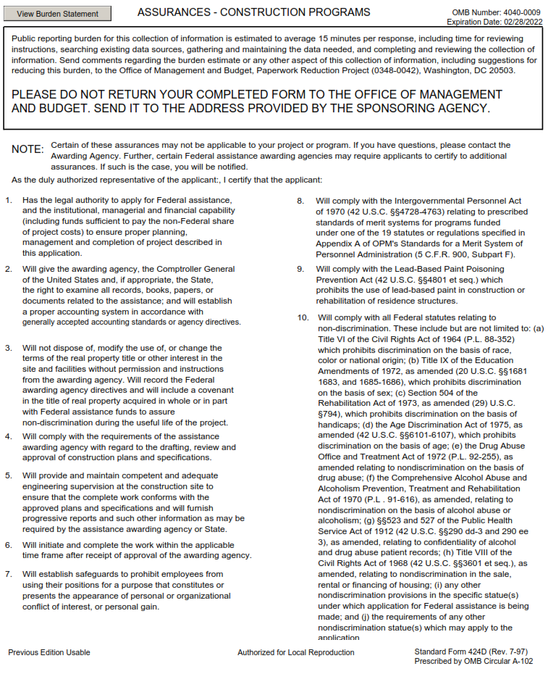

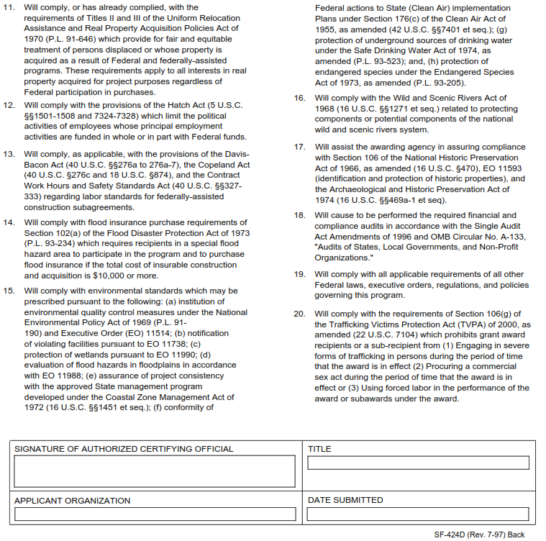

EXHIBIT 5
[Funding Source Identification attached]

EXHIBIT 5

FUNDING SOURCE IDENTIFICATION

Source of Funding: | Federal | State | City
Name of Awarding Agency:
Award Title:
Award Id. #:
CFDA Id. #:
Term of Award:
Award Amount:
City Account #:

1. The Consultant acknowledges that the funding of this Agreement is from federal, state, and/or City funds. The identification of the source of funding is indicated above. As applicable, the Consultant shall comply with the requirements of the funding source, including but not limited to the terms and conditions of the notice of grant award, statutes and regulations, and manuals.
2. As applicable, the Consultant shall comply with the assurances and certifications, which are attached hereto and incorporated herein.
3. The Consultant agrees to accept any additional conditions governing the use of funds or performance of programs as may be required by executive order, federal, state or local statute, ordinance, rule or regulation or by policy announced by the City. However, should the Consultant find such additional condition or conditions unacceptable, the Consultant may terminate this Agreement upon thirty (30) days written notice.

