INTER-AGENCY AGREEMENT
BETWEEN
THE MAYOR’S OFFICE OF RECOVERY PROGRAMS
AND
PROVIDE AGENCY NAME

THIS INTER-AGENCY AGREEMENT (“Agreement”) is made between two agencies of the Mayor and City Council of Baltimore (“City”), namely the Mayor’s Office of Recovery Programs (“MORP”) and the PROVIDE AGENCY NAME (“Department”).

WHEREAS, the 2021 American Rescue Plan Act (“ARPA”) provided $641.1 million to the City from the Coronavirus State and Local Recovery Fund (“SLFRF”), which consists of the Coronavirus State Fiscal Recovery Fund (“CSFRF”) and Coronavirus Local Fiscal Recovery Fund (“CLFRF”) (hereinafter, collectively, called “ARPA funding”);

WHEREAS, the U.S. Department of Treasury is the federal agency that administers the ARPA funding and has provided the City with the ARPA funding conditional on the City complying with its rules and regulations;

WHEREAS, the City has established a process for City agencies and organizations external to the City to apply for ARPA funding;

WHEREAS, MORP has administered the process for ARPA funding and recommends the Department receive ARPA funding for its program as described in this Agreement;

WHEREAS, MORP and the Department wish to enter into this Agreement to memorialize each other’s responsibilities in regard to the ARPA funding for the program; and

NOW, THEREFORE, THIS AGREEMENT WITNESSETH that in consideration of the mutual promises contained herein and for other good and valuable consideration, the receipt and sufficiency of which is hereby acknowledged, the parties hereto agree as follows:

A. PURPOSE

MORP hereby agrees to provide ARPA funding, in the amount set forth herein, to the Department to facilitate the implementation of the program.

B. SCOPE OF PROGRAM

Department shall implement the program, including any milestones and deliverables, as described in Exhibit 1, which is appended hereto and made a part of this Agreement.

C. TERM

The term of this Agreement shall begin on PROVIDE START DATE and end on PROVIDE END DATE, unless terminated earlier in accordance with this Agreement.

D. FINANCIAL AND PERFORMANCE REQUIREMENTS

1. Funding. Subject to the availability of ARPA funding, MORP shall provide funds to the Department for the program, in an amount not to exceed PROVIDE DOLLAR AMOUNT ($ .00) for the term. Any expenses/costs incurred by Department in excess of this amount shall be the sole responsibility of Department.

2. Budget. Department agrees that all expenditures are to be in accordance with the approved budget for the term of this Agreement. The approved budget is part of the proposal at Exhibit 1.
3. Payment. The City shall make ARPA funding as specified in this Agreement available for use. The ARPA funding shall be used to provide the services described in this Agreement and in Exhibit 1. The Department shall comply with the ARPA funding requirements listed at Exhibits 2 and 3. Any ARPA funding advanced to Department prior to the execution of this Agreement which is related to this Agreement is subject to the terms and conditions of this Agreement.
4. Reporting. The Department agrees to provide supporting documents and corresponding reports as requested by the U.S. Department of the Treasury and MORP to meet any reporting deadlines. The Department shall adhere to the instructions and format, including specific forms required by MORP and the U.S Department of Treasury for the ARPA funding. Reporting terms and conditions are provided in Exhibit 4.
5. Audits. The Department shall comply with all applicable provisions of the federal Uniform Guidance (2 CFR 200), including the Cost Principles and Single Audit Act requirements. At any time during business hours and as often as the City, State, or Federal agencies may deem necessary, there shall be made available to the government agency for examination, the Department’s records with respect to matters covered by this Agreement. The Department shall permit the City, State, or Federal agencies to audit, examine, and make excerpts or transcripts from such records, and to make audits of all contracts, invoices, materials, records of personnel, conditions of employment and other data relating to matters covered by this Agreement.
6. Records. The Department shall retain records related to this Agreement for a period of five (5) years after all funds have been expended or returned to the U.S. Department of Treasury, whichever is later.
7. Performance Management. The Department shall collect performance data from subrecipients and grantees, as applicable, to measure progress towards achieving each grant’s specific goals and objectives. The Department is required to establish performance reporting deadlines for subrecipients and grantees, as applicable, that match the reporting deadlines established in this Agreement (Exhibit 4). For example, if the Department reports to MORP monthly, then the Department is expected to collect performance data on a monthly basis. The Department should document the methodology for collecting and calculating performance data and use performance reports from subrecipients and grantees, as applicable, as the basis for monitoring, corrective action, and overall grant management.
8. Subrecipient and Grantee Monitoring. The Department shall conduct regular, consistent, and documented monitoring and oversight activities with subrecipients and grantees, as applicable, to ensure compliance with standards and progress towards each grant’s specific goals and objectives. The results of those activities should be used to correct deficiencies and provide technical assistance to subrecipients and grantees, as necessary and applicable. Monitoring activities may include on-sight visits, staff interviews, review of program documentation, review of internal controls, including financial systems, risk assessments, and other related activities. The type and frequency of monitoring activities must be based on a documented risk assessment and modified, as necessary, over each grant’s performance period based on documented performance and compliance.
E. CORRECTIVE ACTION AND TERMINATION

1. Corrective Action. Upon written notice, MORP may require the Department to take corrective action so the Department is in compliance with federal, state, or local laws, regulations, or rules related to the ARPA funding for the program. Corrective action may be required for but is not limited to instances in which the Department: (a) fails to file a report, (b) fails to meet performance standards, (c) fails to meet milestones or timelines, or (d) misuses funds. MORP may require corrective action of the Department, including but not be limited to: (a) a written warning, (b) additional technical assistance, (c) additional monitoring, (d) program suspension, and (e) reduction/repayment of funding.

2. Termination. Either party may terminate this Agreement by giving to the other party written notification prior to termination. Upon termination, the parties hereto agree that all reports and supporting documentation required for services rendered pursuant to this Agreement shall be provided to MORP forthwith. Any funds advanced to the Department for services not yet rendered shall be returned to the MORP immediately.

F. MODIFICATIONS AND AMENDMENTS

The Department may submit a written request to MORP asking for (i) an extension to the term of this Agreement; and/or (ii) a budget reallocation not to exceed twenty-five (25) percent of the ARPA funding. The request should include an explanation for why an extension and/or program budget reallocation is needed and be provided to MORP at least sixty (60) days prior to the expiration date of this Agreement. The request must include all required documentation to justify the need for an extension and/or reallocation. MORP will approve or deny the request in writing. The Department may not expend the ARPA funding under a reallocated program budget until such time they have received written approval from MORP. Any additional funds or other modifications may be added to this Agreement by written Amendment setting forth the modifications/ amendments signed by the parties and approved by the Board of Estimates of Baltimore City, if applicable.

G. GENERAL PROVISIONS AND CONDITIONS

1. Compliance with Laws. The parties shall comply with all federal, state, and local laws, ordinances, rules, regulations, interim expenditure and annual report requirements, and applicable codes of ethics, pertaining to or regulating the services to be performed pursuant to this Agreement, including those now in effect and hereafter adopted. Any violation of such laws, ordinances, rules, regulations, or applicable codes of ethics by the Department shall constitute a material breach of this Agreement and shall entitle MORP to terminate this Agreement immediately upon delivery of written notice of termination to the Department.

2. Nondiscrimination. The parties shall operate under this Agreement so that no person, otherwise qualified, is denied employment or other benefits on the grounds of race, color, sex, religion, national origin, ancestry, age, physical or mental disability or sexual orientation except where a particular occupation or position reasonably requires consideration of these attributes as an essential qualification for the position. The Department shall post in conspicuous places, available to employees and applicants for employment, notices setting forth the provisions of this non-discrimination clause.

3. No Duplication of Funding. The Department shall not use different sources of federal funding to pay for the same services. The Department shall not use ARPA funding to pay for the same work that was reimbursed or paid by other sources of funding (e.g., FEMA or CARES funding).

4. Governing Law and Venue. This Agreement shall be construed by and governed under the laws of the State of Maryland and subject to the jurisdiction of a court of competent jurisdiction in Baltimore City.

5. No Assignment. This Agreement shall not be assigned by the Department to another party without the prior written approval of MORP. This Agreement shall be binding upon the parties hereto and their successors and assigns.

6. Notice. Any notice required or permitted under this Agreement shall be in writing, be delivered by a reasonable and verifiable means (e.g., in person, mail, or e-mail) and be considered delivered upon receipt of the other party.

FOR MORP:  Shamiah T. Kerney, Chief Recovery Officer  Mayor’s Office of Recovery Programs  100 N. Holliday Street  Baltimore, Maryland 21202  shamiah.kerney@baltimorecity.gov  AND A COPY TO:  Baltimore City Department of Law  100 N. Holliday Street, Suite 101  Baltimore, Maryland 21202 | FOR DEPARTMENT:  ____________________________  ____________________________  ____________________________  ____________________________

7. Headings. Any heading of the paragraphs in this Agreement is inserted for convenience and reference only and shall be disregarded in construing and/or interpreting this Agreement.

8. Incorporation. The recitals and exhibits are hereby incorporated as part of this Agreement.

9. Final Agreement. This Agreement constitutes the entire, full, and final understanding between the parties hereto and neither party shall be bound by any representations, statements, promises or agreements not expressly set forth herein.

[SIGNATURE PAGE FOLLOWS]

IN WITNESS WHEREOF, the parties hereby evidence their agreement to the above terms and conditions by having caused this Agreement to be executed below.

MAYOR’S OFFICE OF RECOVERY PROGRAMS

By: ________________________________
WITNESS Shamiah Kerney, Chief Recovery Officer

PROVIDE AGENCY NAME

By: __________________________________

WITNESS Name/Title:

APPROVED AS TO FORM AND LEGAL APPROVED BY THE BOARD OF ESTIMATES
SUFFICIENCY

____________________________________ __________________________________________
Assistant/Chief Solicitor Clerk Date

EXHIBIT 1

SCOPE OF SERVICES AND BUDGET

- The Department will implement the program in accordance with its proposal, as approved by MORP, which is attached hereto and incorporated herein.

- The Department’s implementation of the program may include but not be limited to contracting with subrecipients, grantees, or contractors, providing programmatic monitoring and oversight of subrecipients or grantees, as applicable, providing budget oversight, drafting reports, and overseeing program evaluation.

- The Department supported by MORP will provide grant management, fiscal, and programmatic oversight for the subrecipients or grantees, as applicable.

- The Department will work with subrecipients, grantees, and contractors to track program outcomes and will provide draft program reports to MORP as requested. Information from the reports will be summarized and sent to the U.S. Department of Treasury by MORP.

- The Department will receive invoices from subrecipients, grantees, and contractors, track expenditures, and complete draft fiscal reports for submission to MORP.

- The Department supported by MORP will provide technical assistance and operational support to subrecipients or grantees, as needed.

- The Department shall follow the instructions of MORP related to compliance with ARPA funding requirements.

[ATTACH PROPOSAL APPROVED BY MORP BEHIND THIS PAGE]

EXHIBIT 2

FUNDING SOURCE IDENTIFICATION

Source of Funding: | Federal
Name of Awarding Agency: | U.S. Department of Treasury
Award Title: | American Rescue Plan Act (“ARPA”) – Coronavirus State Fiscal Recovery Fund and Coronavirus Local Fiscal Recovery Fund, which together make up the Coronavirus State and Local Fiscal Recovery Funds
Assistance Listing Number: | 21.027
City Award Identification Number:
Term of Award:
Award Amount: | $_____________________
Cost Center:
Worktag:

1. Department acknowledges that the funding of this Agreement is from federal, state, and/or City funds. The identification of the source of funding is indicated above. As applicable, Department shall comply with the requirements of the funding source, including but not limited to the terms and conditions of the notice of grant award, statutes and regulations, and manuals. Specific requirements of the funding source are incorporated herein, which include but are not limited to the following:
- Sections 602 and 603 of the Social Security Act, as added by Section 9901 of ARPA;
- Coronavirus State and Local Fiscal Recovery Funds Guidance on Recipient Compliance and Reporting Responsibilities, the most current version;
- “Treasury’s Portal for Recipient Reporting State and Local Fiscal Recovery Funds, the most current version;
- Coronavirus State and Local Fiscal Recovery Funds Final Rule, codified at 31 CFR Part 35 and effective April 1, 2022;
- Coronavirus State and Local Fiscal Recovery Funds Frequently Asked Questions, the most current version;
- 2 C.F.R. Part 200 – Uniform Administrative Requirements, Cost Principles, and Audit Requirements for Federal Awards, other than such provisions as the Treasury may determine are inapplicable to the ARPA funding and subject to such exceptions as may be otherwise provided by the Treasury; and
- U.S. Department of the Treasury Coronavirus State and Local Fiscal Recovery Fund Award Terms and Conditions attached hereto as Exhibit 3. The term “Recipient” in the foregoing shall mean the Department.
2. With respect to any conflict between the funding source requirements, this Exhibit, the terms of this Agreement or the provisions of state law, and except as otherwise required under federal law or regulation, the more stringent requirement shall control and shall amend the Agreement to the extent, and only to the extent, of the conflict.
3. Department agrees to accept any additional conditions governing the use of funds or performance of programs as may be required by executive order, federal, state, or local statute, ordinance, rule, or regulation or by policy announced by the City.
EXHIBIT 3

AWARD TERMS AND CONDITIONS

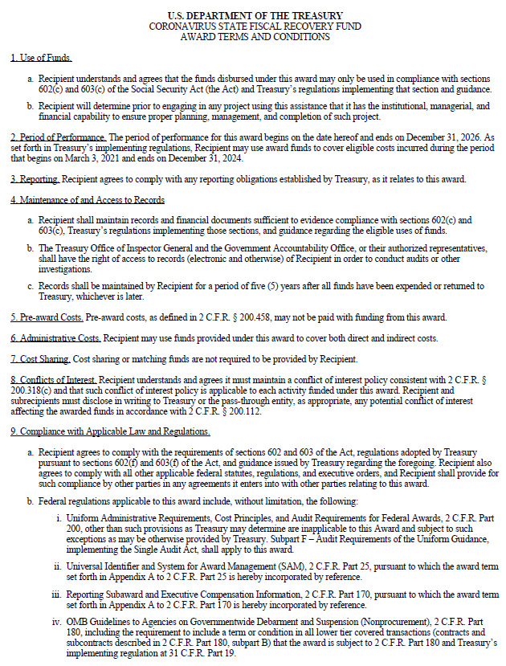

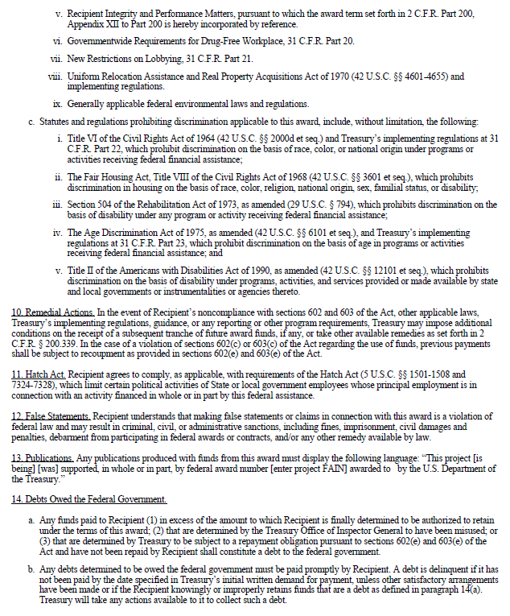

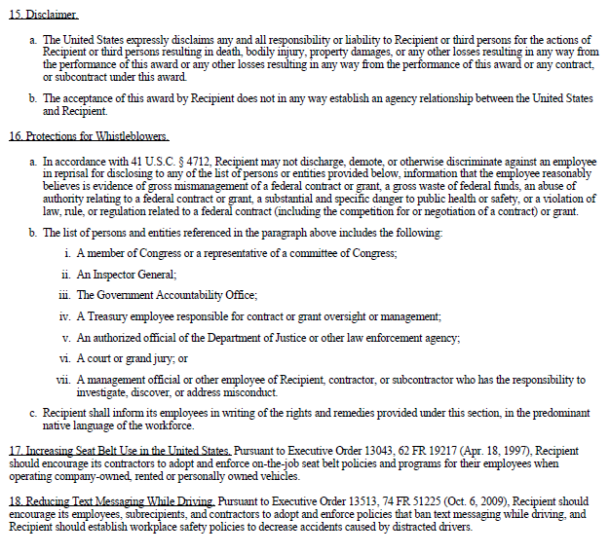

EXHIBIT 4

REPORTING TERMS AND CONDITIONS

The Department shall submit performance reports about the activities funded under this Agreement. Reports shall provide the necessary information by using the web portal established by the MORP for that purpose. The Recovery Office will meet with the Department on quarterly basis to discuss performance, unless otherwise determined.

Performance Reports
All monthly reports of finances, expenditures, and performance measures on ARPA-funded projects should be submitted to the Mayor’s Office of Recovery Programs by the second Friday of each calendar month. Every month, the Department will provide a narrative report on all project activities. Reporting frequency subject to change.

Reporting deadlines prior to the approval of the agreement by the Board of Estimates do not apply. Reporting deadlines after the end of the award term do not apply.

Calendar Year |  |  | Period of Activity | Monthly Report  Due Date
 | 2022 |  | April 1, 2022 - April 30, 2022 | May 13, 2022
 | 2022 |  | May 1, 2022 - May 31, 2022 | June 10, 2022
 | 2022 |  | June 1, 2022 - June 30, 2022 | July 8, 2022
 | 2022 |  | July 1, 2022 - July 31, 2022 | August 12, 2022
 | 2022 |  | August 1, 2022 - August 31, 2022 | September 9, 2022
 | 2022 |  | September 1, 2022 - September 30, 2022 | October 14, 2022
 | 2022 |  | October 1, 2022 - October 31, 2022 | November 14, 2022*
 | 2022 |  | November 1, 2022 - November 30, 2022 | December 9, 2022
 | 2022 |  | December 1, 2022 - December 31, 2022 | January 13, 2023
 | 2023 |  | January 1, 2023 - January 31, 2023 | February 10, 2023
 | 2023 |  | February 1, 2023 - February 28, 2023 | March 10, 2023
 | 2023 |  | March 1, 2023 - March 30, 2023 | April 14, 2023
 | 2023 |  | April 1, 2023 - April 30, 2023 | May 12, 2023
 | 2023 |  | May 1, 2023 - May 31, 2023 | June 9, 2023
 | 2023 |  | June 1, 2023 - June 30, 2023 | July 14, 2023
 | 2023 |  | July 1, 2023 - July 31, 2023 | August 11, 2023
 | 2023 |  | August 1, 2023 - August 31, 2023 | September 8, 2023
 | 2023 |  | September 1, 2023 - September 30, 2023 | October 13, 2023
 | 2023 |  | October 1, 2023 - October 31, 2023 | November 13, 2023*
 | 2023 |  | November 1, 2023 - November 30, 2023 | December 8, 2023
 | 2023 |  | December 1, 2023 - December 31, 2023 | January 12, 2024
 | 2024 |  | January 1, 2024 – January 31, 2024 | February 9, 2024
 | 2024 |  | February 1, 2024 – February 28, 2024 | March 8, 2024
 | 2024 |  | March 1, 2024 – March 31, 2024 | April 12, 2024
 | 2024 |  | April 1, 2024 – April 30, 2024 | May 10, 2024
 | 2024 |  | May 1, 2024 – May 31, 2024 | June 14, 2024
 | 2024 |  | June 1, 2024 – June 30, 2024 | July 12, 2024
 | 2024 |  | July 1, 2024 – July 31, 2024 | August 9, 2024
 | 2024 |  | August 1, 2024 – August 31, 2024 | September 13, 2024
 | 2024 |  | September 1, 2024 – September 30, 2024 | October 11, 2024
 | 2024 |  | October 1, 2024 – October 31, 2024 | November 8, 2024
 | 2024 |  | November 1, 2024 – November 30, 2024 | December 13, 2024
 | 2024 |  | December 1, 2024 – December 31, 2024 | January 10, 2025
 | 2025 |  | January 1, 2025 – January 31, 2025 | February 14, 2025
 | 2025 |  | February 1, 2025 – February 28, 2025 | March 14, 2025
 | 2025 |  | March 1, 2025 – March 31, 2025 | April 11, 2025
 | 2025 |  | April 1, 2025 – April 30, 2025 | May 9, 2025
 | 2025 |  | May 1, 2025 – May 31, 2025 | June 13, 2025
 | 2025 |  | June 1, 2025 – June 30, 2025 | July 11, 2025
 | 2025 |  | July 1, 2025 – July 31, 2025 | August 15, 2025
 | 2025 |  | August 1, 2025 – August 31, 2025 | September 12, 2025
 | 2025 |  | September 1, 2025 – September 30, 2025 | October 10, 2025
 | 2025 |  | October 1, 2025 – October 31, 2025 | November 14, 2025
 | 2025 |  | November 1, 2025 – November 30, 2025 | December 12, 2025
 | 2026 |  | December 1, 2025 – December 31, 2025 | January 9, 2026
 | 2026 |  | January 1, 2026 – January 31, 2026 | February 13, 2026
 | 2026 |  | February 1, 2026 – February 28, 2026 | March 13, 2026
 | 2026 |  | March 1, 2026 – March 31, 2026 | April 10, 2026
 | 2026 |  | April 1, 2026 – April 30, 2026 | May 8, 2026
 | 2026 |  | May 1, 2026 – May 31, 2026 | June 12, 2026
 | 2026 |  | June 1, 2026 – June 30, 2026 | July 10, 2026
 | 2026 |  | July 1, 2026 – July 31, 2026 | August 14, 2026
 | 2026 |  | August 1, 2026 – August 31, 2026 | September 11, 2026
 | 2026 |  | September 1, 2026 – September 30, 2026 | October 9, 2026
 | 2026 |  | October 1, 2026 – October 31, 2026 | November 13, 2026
 | 2026 |  | November 1, 2026 – November 30, 2026 | December 11, 2026
 | 2027 |  | December 1, 2026 – December 31, 2026 | January 8, 2027
* Deadline modified due to a holiday on the second Friday of the month.

Expenditure Category: [LIST EXPENDITURE CATEGORY]

Performance reports shall provide the following information: [LIST PERFORMANCE MEASURES]

