AMERICAN RESCUE PLAN ACT GRANT AGREEMENT BY AND BETWEEN
THE MAYOR AND CITY COUNCIL OF BALTIMORE
AND
PROVIDE GRANTEE’S LEGAL NAME

THIS AMERICAN RESCUE PLAN ACT GRANT AGREEMENT (this “Agreement”) is entered into by and between the MAYOR AND CITY COUNCIL OF BALTIMORE, a municipal corporation of the State of Maryland (the “City”), acting by and through the Mayor’s Office of Recovery Programs, and PROVIDE GRANTEE’S LEGAL NAME (the “Grantee”).
WHEREAS, the American Rescue Plan Act of 2021, through the State and Local Fiscal Recovery Fund, has provided $641 million in one-time funding to the City to respond to the COVID-19 public health emergency and its negative economic impacts (“ARPA Funding”);
WHEREAS, the Grantee provides PROVIDE GENERAL STATEMENT OF THE PROGRAM in Baltimore City (the “Program”);

WHEREAS, the parties hereto wish to enter into this Agreement according to the terms and conditions herein.
NOW, THEREFORE THIS AGREEMENT WITNESSETH THAT, for and in consideration of the promises, mutual covenants, obligations and the benefits and undertakings herein expressed, and for other good and valuable consideration, the receipt and sufficiency of which is hereby acknowledged, the parties agree to the following terms and conditions:
A. PURPOSE
The purpose of this Agreement is to provide the Grantee with the Grant Funds that will support the Grantee’s Program, as more specifically set forth on Exhibit A, attached hereto and incorporated herein.
B. IDENTIFICATION OF FUNDING
It is anticipated that federal funding will be used for this Agreement. The Grantee shall comply with the applicable funding requirements identified in Exhibit B, attached hereto and incorporated herein. Additionally, the Grantee agrees to execute and comply with the Award Terms and Conditions, attached hereto as Exhibit C, and incorporated herein. Any references in Exhibit C to “Recipient” are deemed to refer to Grantee, as a subrecipient of the City.
C. TERM
This Agreement shall commence on PROVIDE START DATE and shall terminate on PROVIDE END DATE, unless terminated earlier pursuant to the terms of this Agreement.
D. SCOPE OF THE PROGRAM
The Grantee’s responsibilities shall include, but are not limited to those activities provided for in Exhibit A.
E. DISBURSEMENT OF FUNDS
1. The City shall pay the Grantee an amount not to exceed PROVIDE DOLLAR AMOUNT ($ .00) (the “Grant Funds”). Any expenses/costs incurred by the Grantee in excess of that amount shall be the sole responsibility of the Grantee.
- The Grantee will invoice the City for payment under this Agreement in accordance with the Invoicing Procedures identified in Exhibit D, attached hereto and incorporated herein. The City shall make reasonable efforts to pay the Grantee within thirty (30) days of the receipt and approval of a documented invoice from the Grantee. The invoice for payment shall be timely, indicate the time periods and services for which payment is requested, and shall adhere to instructions, format, and form as required by the City.
- The Grantee shall use the Grant Funds for the activities and pursuant to the Approved Budget set forth in Exhibit A.
- The Grantee agrees that all expenditures are to be in accordance with the terms of this Agreement. The Grantee further agrees to comply with the requirements contained in any applicable City, State, or Federal grant awards, statutes and regulations, and manuals such as are revised from time to time.
- No Duplication of Funding. The Grantee shall not use different sources of federal funding to pay for the same services. The Grantee shall not use Grant Funds to pay for the same work that was reimbursed or paid by other sources of funding (e.g., FEMA or CARES funding).
F. REPORTS
As requested by the City, the Grantee shall submit reports about the activities funded under this Agreement. The reports shall be in accordance with the format and content required by the City. The Grantee shall refer to the Reporting Terms and Conditions Exhibit, attached hereto as Exhibit E.
G. INDEMNIFICATION
The Grantee shall indemnify and hold harmless the Mayor and City Council of Baltimore, its elected/appointed officials, departments, employees, agents, servants, and volunteers from any and all claims, demands, suits, and actions, including reasonable attorneys’ fees connected therewith, brought against the Mayor and City Council of Baltimore, its elected/appointed officials, departments, employees, agents, servants, and volunteers arising as a result of any direct or indirect, willful, or negligent act or omission of the Grantee pursuant to the performance of this Agreement.
H. INSURANCE
The Grantee shall procure and maintain during the life of this Agreement the following insurance coverages:
1. Commercial General Liability Insurance at limits of not less than One Million Dollars ($1,000,000) per occurrence for claims arising out of bodily injuries or death, and property damages. With those polices with aggregate limits, a minimum limit of Three Million Dollars ($3,000,000) is required. Such insurance shall include contractual liability insurance.
2. Business Automobile Liability at limits of not less than One Million Dollars ($1,000,000) per occurrence for claims arising out of bodily injuries of death, and property damages. The insurance shall apply to any owned, non-owned, leased or hired automobiles used in the performance of this Agreement.
3. Blanket Crime Insurance including Employee Theft and Forger or Alteration to insure the City against any and all loss of the Grant Funds provided hereunder to misuse, mismanagement, and/or theft of funds by the Grantee, its directors/members, officers, employees, agents or assigns.
4. Worker’s Compensation coverage as required by the State of Maryland, as well as any similar coverage required for this work by applicable Federal or “Other States” State Law.
5. The City, its elected/appointed officials, employees, departments, and agents shall be covered, by endorsement, as additional insureds with respect to liability arising out of activities performed by or on behalf of the Grantee in connection with this Agreement.
6. The Grantee’s insurance shall apply separately to each insured against whom claim is made and/or lawsuit is brought, except with respect to the limits of the insurer’s liability.
7. Insurance is to be placed within insurers with a Best’s rating of no less than A:VII, or, if not rated with Best’s, with minimum surpluses the equivalent of Best’s surplus size VII and must be licensed/approved to do business in the State of Maryland.
8. Coverage shall not be suspended, voided, canceled, reduced in coverage or in limits, except by the reduction of the applicable aggregate limit by claims paid, until after forty-five (45) days prior written notice has been given to the City. There will be an exception for non-payment of premium, which is ten (10) days’ notice of cancellation.
9. Failure to obtain insurance coverage as required shall constitute an immediate breach of this Agreement.
I. MODIFICATIONS AND AMENDMENTS
The Grantee may submit a written request to the City asking for (x) an extension to the term of this Agreement; and/or (y) a budget reallocation not to exceed twenty-five (25) percent of the Grant Funds. The request should include an explanation for why an extension and/or budget reallocation is needed and be provided to the City at least sixty (60) days prior to the expiration date of this Agreement. The request must include all required documentation to justify the need for an extension and/or reallocation. The Chief Recovery Officer or their designee will approve or deny the request in writing. The Grantee may not expend the Grant Funds under a reallocated budget until such time they have received written approval from the Chief Recovery Officer. Such unapproved expenditure of the Grant Funds could result in a failure to approve the Grant Funds for payment. Any additional funds or other modifications may be added to this Agreement by written Amendment setting forth the modifications/amendments signed by the parties and approved by the Board of Estimates of Baltimore City (the “Board”).
J. DEFAULT AND REMEDIES
1. The following shall constitute a default of Grantee under this Agreement:
i. Breach of any of Grantee’s covenants, agreements, or certifications in this Agreement, including the expenditure of Grant Funds for any use other than for the purposes set forth in the Program guidelines or in an unauthorized manner; or
ii. Grantee’s failure to comply with federal, state, or local laws, regulations, or rules related to the Grant Funds for the Program.
2. Upon occurrence of any default, the City shall have the right to terminate this Agreement by written notice to the Grantee. To the extent that any such default is curable, the Grantee shall have ten (10) business days from the date the City’s notice is postmarked or sent via electronic mail (whichever is sooner) to cure the default. After the conclusion of the ten (10) business day period, if the Grantee has not cured or commenced to cure the default to the satisfaction of the City, the City may, at its option:
i. Assist the Grantee in curing the default;
ii. Suspend its disbursement of Grant Funds to Grantee until such time as the default has been cured by Grantee; or
iii. Immediately terminate this Agreement for cause.
3. In the event the City terminates this Agreement for cause:
i. Grantee’s authority to request disbursements shall cease and Grantee shall have no right, title, or interest in or to any of the Grant Funds not already disbursed;
ii. The City may demand repayment from the Grantee of any amounts the City determines were not expended in accordance with this Agreement;
iii. The City, at its sole discretion, may demand repayment of all Grant Funds disbursed to Grantee; and
iv. The City, at its sole discretion, may bar the Grantee from reapplying to participate in the Program.
4. In addition to the rights and remedies contained in this Agreement, the City may at any time, proceed to protect and enforce all rights available to the City by suit in equity, action at law, or by any other appropriate proceedings, all of which rights and remedies shall survive the termination of this Agreement.
5. Termination for Convenience. Either party shall have the right to terminate this Agreement at any time during the term of this Agreement, for any reason, including without limitation, its own convenience, upon thirty (30) days’ prior written notice to the other party. Within thirty (30) days of such termination, Grantee shall be paid in full for services provided up to the effective date of the termination and shall return to the City all funding under this Agreement that has not been expended for activities under this Agreement.
6. Appropriations. The payment of invoices and any amounts due Grantee under this Agreement is contingent upon the proper appropriation of funds by the Baltimore City Council in accordance with the Baltimore City Charter and Code. If funds are not appropriated for payment under this Agreement, the City may terminate this Agreement without the assessment of any charges, fees or financial penalties against the City by providing written notice of intent to terminate to Grantee. Grantee shall not begin any additional services related to this Agreement upon receipt of notification of intent to terminate by the City.
K. RETENTION OF RECORDS
The Grantee shall maintain such records and accounts which support the services provided in this Agreement, for a period of five (5) years after all Grant Funds have been expended or returned to the U.S. Department of Treasury, whichever is later., except where unresolved audit questions require retention for a longer period as determined by the City. These records shall be available during regular business hours, for audit purposes and inspection, to the City or any authorized representative of the City. If the Grantee should cease to exist, custody of all records related to this Agreement will be transferred to the City.
L. AUDIT
The City requires grantees to have an annual audit at its own (grantee’s) expense to coincide with its fiscal year to be performed by an independent audit firm. The Grantee must ensure that any independent auditor engaged to perform their Uniform Guidance audit is qualified and meets Generally Accepted Government Auditing Standards (GAGAS) as issued by the Comptroller General of the United States.
1. If Grantee expends $750,000 or more in federal source funds in its fiscal year, it shall engage at its own expense an independent audit firm to perform an annual audit based on its fiscal year in compliance with the requirements of 2 C.F.R. 200 and the Uniform Administrative Requirements, Cost Principles, and Audit Requirements for Federal Awards (“Uniform Guidance”) as promulgated by the United States Office of Management and Budget (“OMB”).
2. If the Grantee receives less than $750,000 in federal source funds in its fiscal year, it shall engage at its own expense an independent auditor to perform a financial statement audit based on its fiscal year in accordance with 2 C.F.R. 200, Subpart F and Uniform Guidance.
3. The Grantee shall submit an original bound audit report and all management letters in hardcopy and pdf versions to the City within the nine (9) months after the end of its fiscal year. The Grantee shall send the appropriate audit report to the City.
4. Irrespective of the amount of the award and of the particular audit requirements, the City has the right to perform periodic fiscal and programmatic reviews and audits of the records and books of the Grantee. The City also has the right to request the Baltimore City Department of Audits to perform a review or an audit of the Grantee.
5. The Grantee agrees to comply with all federal, state, and local requirements related to the award.
6. The Grantee shall be responsible for repayment of any and all applicable audit exceptions, which may be identified by City, state, or federal auditors or their designated representatives, and reviewed by the Grantee. The Grantee will be billed by the City for the amount of said audit disallowance and shall promptly repay such audit disallowance. In the event of such an audit disallowance, the City may offset the current fiscal year award or subsequent year award by the amount of such audit disallowance.
M. CONFIDENTIALITY
The Grantee represents that any confidential information (as identified by the City) received from the City in the furtherance of this Agreement shall remain strictly confidential and shall not be made available to any individual or organization other than the Grantee’s employees and board members without prior verbal or written approval of the City. Prior consent by the City is not required for information, or any portion thereof, which was within the public domain at the time of its disclosure or is required to be produced in response to subpoena, court order or other legal proceeding, or by law and the Grantee provides notice to the City of such request before releasing the information. The Grantee agrees to comply and cooperate with requests for information pursuant to the Maryland Public Information Act, Md. Ann. Code GP, § 4-101, et seq.
The City reserves the right to reproduce and distribute at its own expense any report, information, data, or materials prepared or assembled by the Grantee pursuant to this Agreement or any portion thereof. The City shall acknowledge the Grantee and its involvement in any such reproduction or distribution and the City shall not alter or misrepresent any data or materials provided. The provisions of this section shall survive the termination of this Agreement.
N. PUBLICATION
The Grantee agrees to use its best efforts to publicly recognize and publicize the amount of the City grant in remarks delivered at public events, in all formal written materials such as newsletters and reports intended for widespread or public distribution, and in all website and other electronic communications that have a public affairs purpose and that relate to the activities funded by this Agreement. In the event that the Grantee wishes to issue a news release related to this Agreement, to the extent possible, the text of the release should be submitted to the City for review prior to the release date.
O. COMPLIANCE WITH LAWS
The Grantee shall comply with all federal, state and local laws, ordinances, rules and regulations as well as applicable codes of ethics, pertaining to or regulating the provision of the services, including those now in effect and hereafter adopted. Any violation of such laws, ordinances, rules and regulations, and applicable codes of ethics shall constitute a material breach of this Agreement and shall entitle the City to terminate this Agreement immediately upon delivery of written notice of termination to the Grantee.
P. CRIMINAL BACKGROUND CHECKS
As applicable pursuant to Md. Code Ann. Family Law Article, §5-560 et seq., the Grantee shall obtain criminal history records checks of employees, agents, and volunteers who shall provide services to minors under this Agreement. In any case where a criminal record is reported, the Grantee shall be responsible for taking immediate and appropriate action to protect the safety and welfare of any and all persons (especially minors, seniors, and people with disabilities or mental illness) having contact with that individual. All costs of the criminal background check shall be borne by the Grantee.
Q. DISPUTES
The City shall in all cases, determine the amount or quantity, quality, and acceptability of the services of the Grantee which are to be paid under this Agreement; shall decide all questions in relation to said services and the performance thereof, and; shall, in all cases, decide questions which may arise relative to the fulfillment of this Agreement or to the obligations of the Grantee thereunder. To prevent disputes and litigation where Grantee is not satisfied with the decision of the City, Grantee shall submit the dispute to the head of the City agency (or his/her designee) who will decide any dispute, and the head of the City agency’s determination, decision and/or estimate shall be a condition precedent to the right of the City to disburse any monies to the Grantee under this Agreement, and is subject to review on the record by a court of competent jurisdiction.
R. CITY REQUIREMENTS
1. Nondiscrimination. The Grantee shall operate under this Agreement so that no person otherwise qualified is denied employment or other benefits on the grounds of race, color, religion, ancestry, national origin, sex, age, marital status, sexual orientation, disability or other unlawful forms of discrimination except where a particular occupation or position reasonably requires consideration of these attributes as an essential qualification for the position. The Grantee shall post in conspicuous places, available to employees and applicants for employment, notices setting forth the provisions of this nondiscrimination clause.
2. MBE/WBE. The City has an interest in and policy of encouraging the equitable utilization of Minority-Owned Businesses (MBEs) and Women-Owned Businesses (WBEs). Article 5, Subtitle 28 of the Baltimore City Code (the “City Code”) is incorporated into this Agreement by reference. The updates occur on the internet and can be found at http://www.baltimorecity.gov/Government/city CharterCodes.aspx. In identifying available City-certified MBEs and WBEs, the Grantee is encouraged to use the MBE/WBE Directory available from the Minority and Women’s Business Opportunity Office, (410) 396-4355. A signed copy of the Grantee’s Commitment to Comply or Waiver, as applicable, is attached hereto as Exhibit F and incorporated herein.
3. Unfair Labor Practices. Notwithstanding any other provisions in this Agreement, in carrying out its obligations under this Agreement, the Grantee shall comply with the terms of the Board’s Resolution dated June 29, 1994 (if applicable), which states as follows:
i. Contractors, subcontractors, their agents and employees may not engage in unfair labor practices as defined under the National Labor Relations Act and applicable federal regulations and state laws.
ii. Contractors, subcontractors, and their agents may not threaten, harass, intimidate or in any way impede persons employed by them who on their own time exercise their rights to associate, speak, organize, or petition governmental officials with their grievance.
iii. If the Board determines that a contractor, subcontractor, or their agents have violated the policy set forth in this Resolution said contractor, or subcontractor will be disqualified from bidding on City contracts, and if they are currently completing contracts, they will be found in default of their contracts.
4. Local Hiring. Article 5, Subtitle 27 of the Baltimore City Code, as amended (the “Local Hiring Law”) and its rules and regulations apply to every contract for more than $300,000 made by the City, or on its behalf, with any person. The Local Hiring Law also applies to every agreement authorizing assistance valued at more than $5,000,000 to a City-subsidized project. Please visit www.oedworks.com for detailed on the requirements of the law. If applicable, and not otherwise prohibited by the applicable funding requirements, the Local Hiring Law and the Local Hiring Rules and Regulations shall be attached hereto as Exhibit G and incorporated herein.
5. Conflict of Interest.
i. No elected official of the City, nor other officer, employee or agent of the City who exercises any functions or responsibilities in connection with this Agreement, shall have any personal interest, direct or indirect, in this Agreement. By executing this Agreement, the Grantee asserts that it has not engaged in any practice or entered into any past or ongoing agreement that would be considered a conflict of interest with this Agreement. The Grantee agrees to refrain from entering into all such practices or agreements during the term of this Agreement (and any extensions thereto) that could give rise to a conflict of interest. Furthermore, the Grantee asserts that it has fully disclosed to the City any and all practices and/or agreements of whatever nature or duration that could give rise to a conflict of interest and will continue to do so during the term of this Agreement and any extensions thereto.
ii. The Grantee must maintain written standards of conduct covering conflicts of interest and governing the actions of its employees engaged in the selection, award and administration of contracts. No employee, officer, or agent may participate in the selection, award, or administration of a contract supported by a Federal award if he or she has a real or apparent conflict of interest. Such a conflict of interest would arise when the employee, officer, or agent, any member of his or her immediate family, his or her partner, or an organization which employs or is about to employ any of the parties indicated herein, has a financial or other interest in or a tangible personal benefit from a firm considered for a contract. The officers, employees, and agents of the Grantee may neither solicit nor accept gratuities, favors, or anything of monetary value from contractors or parties to subcontracts. The standards of conduct must provide for disciplinary actions to be applied for violations of such standards by officers, employees, or agents of the Grantee.
S. MISCELLANEOUS PROVISIONS
1. No Waiver. A party’s failure to insist on compliance or enforcement of any provision of this Agreement shall not affect its validity or enforceability or constitute a waiver of future enforcement of that provision or of any other provision of this Agreement.
2. Severability. Each provision of this Agreement shall be deemed to be a separate, severable, and independently enforceable provision. The invalidity or breach of any provision shall not cause the invalidity or breach of the remaining provisions or of this Agreement, which shall remain in full force and effect.
3. Governance. This Agreement is made in the State of Maryland and shall be governed by the laws of the State of Maryland, including the applicable statute of limitations, without regard to the conflict of law rules. The legal venue of this Agreement and any disputes arising from it shall be settled in Baltimore City, Maryland. The Grantee hereby irrevocably waives any objections and any right to immunity on the ground of venue or the convenience of the forum, or to the jurisdiction of such courts or from the execution of judgments resulting therefrom.
4. Agency/Independent Parties. Nothing herein contained shall be construed to constitute any party the agent, servant or employee of the other party, except as specifically provided in this Agreement. No party has the authority to act as an agent of the other party except as specifically provided in this Agreement. The City and the Grantee are not in a joint venture or partnership for the purposes of this Agreement. The Grantee is an independent party, and its directors/members, employees, servants and agents are not employees, servants or agents of the City. The Grantee’s directors/members, employees, servants and agents shall not be entitled to receive any City benefits, including workers' compensation.
5. Assignability/Subcontracting. The Grantee shall not assign, transfer, or subcontract any part of this Agreement without the prior written consent of the City.
6. Notice.
All notices, requests, claims, demands and other communications required or permitted under this Agreement (collectively, “Notices”) shall be in writing and be given (i) via email, (ii) by delivery in person, (iii) by a nationally recognized next day courier service, or (iv) by registered or certified mail, postage prepaid, to the address of the party specified in this Agreement or such other address as either party may specify in writing to the following:
For the City:  Shamiah T. Kerney, Chief Recovery Officer  Mayor’s Office of Recovery Programs  100 N. Holliday Street  Baltimore, Maryland 21202  shamiah.kerney@baltimorecity.gov  And a copy to:  Baltimore City Department of Law  100 N. Holliday Street, Suite 101  Baltimore, Maryland 21202 | For the Grantee:  ____________________________ ____________________________  ____________________________

All Notices shall be effective upon receipt by the party to which notice is given.
7. Multiple Copies. This Agreement may be executed in any number of copies and each such copy shall be deemed an original.
8. Recitals. The recitals are hereby incorporated as part of this Agreement.
9. Titles and Headings. All titles and headings in this Agreement are for reference purposes only; they are not intended nor shall they be construed to in any way limit the substantive provisions contained in this Agreement or any part thereof.
10. Exhibits. The attachments appended hereto or delivered pursuant to this Agreement together with all documents incorporated by reference therein, form an integral part of this Agreement and are hereby incorporated into this Agreement wherever reference is made to them to the same extent as if they were set out in full at the point at which such reference is made.
11. Conflicting Provisions. With respect to any conflict between the federal funding requirements, the terms of this Agreement or the provisions of state law, and except as otherwise required under federal law or regulation, the more stringent requirement shall control.
12. Entire Agreement. This Agreement constitutes the entire, full and final understanding between the parties hereto and neither party shall be bound by any representations, statements, promises or agreements not expressly set forth herein. The parties do not intend to sign this Agreement under seal to make it a specialty under Maryland law and hereby agree to impose the standard statute of limitations on this Agreement.
[SIGNATURE PAGE FOLLOWS]

IN WITNESS WHEREOF, the parties hereby evidence their agreement to the above terms and conditions by having caused this Agreement to be executed.

WITNESS MAYOR AND CITY COUNCIL OF
BALTIMORE

________________________________ By: ____________________________________
Shamiah Kerney, Chief Recovery Officer
Mayor’s Office of Recovery Programs

WITNESS PROVIDE GRANTEE’S LEGAL NAME

________________________________ By: ______________________________(Seal)
Name: ________________________________
Title: _________________________________

APPROVED AS TO FORM AND APPROVED BY THE BOARD OF
LEGAL SUFFICIENCY BOARD OF ESTIMATES

________________________________ ______________________________________
Assistant/Chief Solicitor Date Clerk Date

EXHIBIT A

SCOPE OF PROGRAM AND APPROVED BUDGET

EXHIBIT B

FUNDING SOURCE IDENTIFICATION

City: Mayor and City Council of Baltimore, through its Mayor’s Office of Recovery Programs
Grantee (Subrecipient):______________________________________________ (“Grantee”)

Source of Funding: | Federal
Name of Awarding Agency: | U.S. Department of Treasury
Award Title: | American Rescue Plan Act (“ARPA”) – Coronavirus State Fiscal Recovery Fund and Coronavirus Local Fiscal Recovery Fund, which together make up the Coronavirus State and Local Fiscal Recovery Funds
Federal award identification: | SLFRP1967
Federal Award Date of award to the recipient by the Federal Agency: | May 2021
Assistance Listing Number and Title: | 21.027
Pass-through entity, and contact information for awarding official of Pass-through entity: | Shamiah Kerney, Chief Recovery Officer  Shamiah.kerney@baltimorecity.gov
Subrecipient’s unique entity identifier (must match subrecipient name):
Subaward Period of Performance Start and End Date:
Subaward Budget Period Start and End Date:
Amount of Federal Funds Obligated by this action by the pass-through entity to the subrecipient:
Total Amount of Federal Funds Obligated to the subrecipient by the pass-through entity including the current financial obligation:
Total Amount of the Federal Award committed to the subrecipient by the pass-through entity:
Federal award project description, as required to be responsive to the Federal Funding Accountability and Transparency Act (FFATA):
Identification of whether the award is R & D:
Indirect cost rate for the Federal award (including the de minimis rate is charged):
City Award Identification Number:
Term of Award:
Award Amount: | $_____________________
Cost Center:
Grant Worktag:

1. Grantee acknowledges that the funding of this Agreement is from federal, state, and/or City funds. The identification of the source of funding is indicated above. As applicable, Grantee shall comply with the requirements of the funding source, including but not limited to the terms and conditions of the notice of grant award, statutes and regulations, and manuals. Specific requirements of the funding source are incorporated herein, which include but are not limited to the following:
- Sections 602 and 603 of the Social Security Act, as added by Section 9901 of ARPA;
- Coronavirus State and Local Fiscal Recovery Funds Guidance on Recipient Compliance and Reporting Responsibilities, the most current version;
- Treasury’s Portal for Recipient Reporting State and Local Fiscal Recovery Funds, the most current version;
- Coronavirus State and Local Fiscal Recovery Funds Interim Final Rule 31 CFR Part 35 dated May 17, 2021;
- Coronavirus State and Local Fiscal Recovery Funds Final Rule 31 CFR Part 35 effective April 1, 2022;
- Coronavirus State and Local Fiscal Recovery Funds Frequently Asked Questions, the most current version;
- 2 C.F.R. Part 200 – Uniform Administrative Requirements, Cost Principles, and Audit Requirements for Federal Awards, other than such provisions as the Treasury may determine are inapplicable to the SLFRF program and subject to such exceptions as may be otherwise provided by the Treasury. This includes, but not limited to, compliance with Subpart F Audit Requirements, 2 C.F.R. § 200.303 regarding internal controls, and §§ 200.330 through 200.332 regarding subrecipient monitoring and management; and
- U.S. Department of the Treasury Coronavirus State and Local Fiscal Recovery Fund Award Terms and Conditions, attached as Exhibit C to this Agreement.

2. With respect to any conflict between the funding source requirements, this Exhibit, the terms of this Agreement or the provisions of federal, state, or city law or regulation, and except as otherwise required under federal, state, or city law or regulation, the more stringent requirement shall control and shall amend the Agreement to the extent, and only to the extent, of the conflict.

3. As applicable, Grantee shall comply with the assurances and certifications, which are set forth below.

4. Grantee agrees to accept any additional conditions governing the use of funds or performance of programs as may be required by executive order, federal, state or local statute, ordinance, rule or regulation or by policy adopted or issued by the City, State, or Federal government.

5. Grantee’s agreements, if any, shall contain a provision making them subject to all of the provisions stipulated in the Agreement.

6. The Grantee, by executing this Exhibit, hereby agrees and acknowledges that Grantee will reimburse the City in a sum equivalent to the amount of any disallowed expenditures in the event that the City, through audit exception or other action, determines that the Grantee’s expenditure of funds, performance of work or submittal of documentation of work performed under this Agreement, including but not limited to work performed by any subcontractor under the Agreement, was not performed in compliance with the Agreement, including this Exhibit or other applicable law. Further, the City reserves the right to set-off any reimbursement obligations owed to the City by Grantee under this provision against any request for payment under the Agreement. This reimbursement obligation will terminate upon the expiration of five (5) years after the expiration or termination of the Agreement.

ASSURANCES AND CERTIFICATIONS
A. ASSURANCES
In performing its responsibilities under this Agreement, Grantee hereby assures that it will fully comply with the following provisions as applicable:
- Shall give the federal awarding agency, the State of Maryland, the City, and the Comptroller General of the United States, through any authorized representative, access to and the right to examine all records, books, papers, or documents related to the award; and will establish a proper accounting system in accordance with generally-accepted accounting standard or agency directives.
- Shall grant the federal awarding agency, the State, and the City a royalty-free, nonexclusive, and irrevocable license to reproduce, publish or otherwise use, and to authorize others to use for government purposes:
  - The copyright in any work developed under a grant, subgrant, or contract under a grant or subgrant; and
  - Any rights of copyright to which a grantee, subgrantee or a contractor purchases ownership with grant support.
- Shall comply with all applicable nondiscrimination statutes, including but not limited to:
  - Title VI of the Civil Rights Act of 1964, as amended, which provides that no person in the United States shall, on grounds of race, color, or national origin be excluded from participation in, be denied the benefits of, or otherwise be subject to discrimination under any program or activity receiving Federal financial assistance;
  - The Fair Housing Act, Title VIII of the Civil Rights Act of 1968, as amended, which prohibits discrimination in housing on the basis of race, color, religion, national origin, sex, familiar status, or disability;
  - Section 504 of the Rehabilitation Act of 1973, as amended, which prohibits discrimination on the basis of disability in Federally-assisted program;
  - Title IX of the Education Amendments of 1972, as amended, which prohibits discrimination on the basis of sex in education programs and activities receiving Federal financial assistance;
  - The Age Discrimination in Employment Act of 1975, as amended, which prohibits discrimination on the basis of age in Federally-assisted programs; and
  - Title II of the Americans with Disabilities Act of 1990, as amended, which prohibits discrimination on the basis of disability under programs, activities, and services provided or made available by stated and local governments or instrumentalities or agencies thereto.
- Shall comply with all applicable audit requirements of Title 2, CFR Grant and Agreements, including but not limited to 2 CFR 200, Subpart F.
- Shall comply with all applicable requirements as the funding is considered to be federal financial assistance subject to the Single Audit Act (31 U.S.C. §§ 7501-7507) and the related provisions of the Uniform Guidance (2. C.F.R. Part 200), 2 C.F.R. § 200.303 regarding internal controls, §§ 200.330 through 200.332 regarding subrecipient monitoring and management, and subpart F regarding audit requirements, which are incorporated herein by reference.
- Shall comply with Title VI of the Civil Rights Act of 1964, which prohibits recipients of federal financial assistance from excluding from a program or activity, denying benefits of, or otherwise discriminating against a person on the basis of race, color, or national origin (42 U.S.C. § 2000d et seq.), which is incorporated herein by reference. Title VI also includes protection to persons with “Limited English Proficiency” in any program or activity receiving federal financial assistance, 42 U.S.C. § 2000d et seq., which is incorporated herein by reference.
- Is encouraged to adopt and enforce on-the-job seat belt policies and programs for your employees when operating company-owned, rented or personally owned vehicles. (Increasing Seat Belt Use in the United States – Executive Order 13043, 62 FR 19217 (Apr. 18, 1997)).
- Is encouraged to adopt and enforce policies that ban text messaging while driving, and to establish workplace safety policies to decrease accidents caused by distracted drivers (Reducing Text Messaging While Driving – Executive Order 13513, 74 FR 51225 (Oct. 6, 2009)).
- Shall comply with 2 C.F.R. 200.216 which provides that Recipients, such as the City, and subrecipients are prohibited from obligating or expending loan or grant funds to: (1) procure or obtain; (2) extend or renew a contract to procure or obtain; or (3) enter into a contract (or extend or renew a contract) to procure or obtain equipment, services, or systems that uses covered telecommunications equipment or services as a substantial or essential component of any system or as critical technology of any system, where “covered telecommunications equipment” has the meaning provided in Public Law 115–232, section 889, including but not limited to telecommunications equipment produced by Huawei Technologies Company or ZTE Corporation (or any subsidiary or affiliate of such entities); or by an entity that the Secretary of Defense, in consultation with the Director of the National Intelligence or the Director of the Federal Bureau of Investigation, reasonably believes to be an entity owned or controlled by, or otherwise connected to, the government of a covered foreign country.
- Shall comply with all other applicable Federal, State, and City laws, executive orders, regulations and policies governing this Agreement.
- Agrees and acknowledges that the Federal Government is not a party to this Agreement and is not subject to any obligations or liabilities to the City, Grantee, or any other party pertaining to any matter resulting from the Agreement.
B. CERTIFICATIONS
1. CERTIFICATION REGARDING DEBARMENT, SUSPENSION, INELIGIBILITY AND VOLUNTARY EXCLUSION – LOWER TIER COVERED TRANSACTIONS.
As required by Executive Orders 12549 and 12689, the undersigned, on behalf of Grantee, certifies that neither it nor its principals are presently debarred, suspended, proposed for debarment, declared ineligible, or voluntarily excluded from participation in this transaction by any federal department or agency.

2. FALSE STATEMENTS.
Grantee understands that making false statements or claims in connection with this contract is a violation of federal law and may result in criminal, civil, or administrative sanctions, including fines, imprisonment, civil damages and penalties, debarment from participating in federal awards or contracts, and/or any other remedy available by law.

3. CERTIFICATION REGARDING LOBBYING.
As required by Section 1352, Title 31 of the United States Code, and implemented for persons entering into a grant or cooperative agreement over $100,000, the undersigned, on behalf of Grantee, certifies, to the best of his or her knowledge and belief, that:
(1) No Federal appropriated funds have been paid or will be paid, by or on behalf of the undersigned, to any person for influencing or attempting to influence an officer or employee of any agency, a Member of Congress, an officer or employee of Congress, or an employee of a Member of Congress in connection with the awarding of any Federal contract, the making of any Federal grant, the making of any Federal loan, the entering into of any cooperative agreement, and the extension, continuation, renewal, amendment, or modification of any Federal contract, grant, loan, or cooperative agreement.
(2) If any funds other than Federal appropriated funds have been paid or will be paid to any person for influencing or intending to influence an officer or employee of any agency, a Member of Congress, an officer or employee of Congress, or an employee of a Member of Congress in connection with this Federal contract, grant, loan, or cooperative agreement, the undersigned shall complete and submit Standard Form-LLL, “Disclosure of Lobbying Activities,” in accordance with its instructions.
(3) The undersigned shall require that the language of this certification be included in the award documents for all subawards at all tiers (including subcontracts, subgrants, and contracts under grants, loans, and cooperative agreements) and that all subrecipients shall certify and disclose accordingly.
This certification is a material representation of fact upon which reliance was placed when this transaction was made or entered into. Submission of this certification is a prerequisite for making or entering into this transaction imposed by section 1352, title 31, U.S. Code. Any person who fails to file the required certification shall be subject to a civil penalty of not less than $10,000.00 and not more than $100,000.00 for each such failure.

Grantee certifies or affirms the truthfulness and accuracy of each statement of its certification and disclosure if any. In addition, Grantee understands and agrees that the provisions of 31 U.S.C. Chap. 38, Administrative Remedies for False Claims and Statement, apply to this certification and disclosure, if any.
4. CERTIFICATION OF NON-DELINQUENCY OF FEDERAL DEBT.
The undersigned, on behalf of Grantee, certifies to the best of his or her knowledge and belief that Grantee is not delinquent in the repayment of any Federal debt as required by 28 U.S.C.S. § 3201.
The undersigned of Grantee further provides assurance that it will include the language of the above certifications in all subawards/subcontracts and that all subrecipients shall certify and disclose accordingly.
As the duly authorized representative of Grantee, I hereby certify that Grantee will comply with the requirements of this Exhibit including the above certifications and has the authority to enter into this Exhibit to the Agreement.

_____________________________________________ _________________________
Signature of Authorized Representative Date

_____________________________________________
Print Name and Title of Authorized Representative

EXHIBIT C

AWARD TERMS AND CONDITIONS
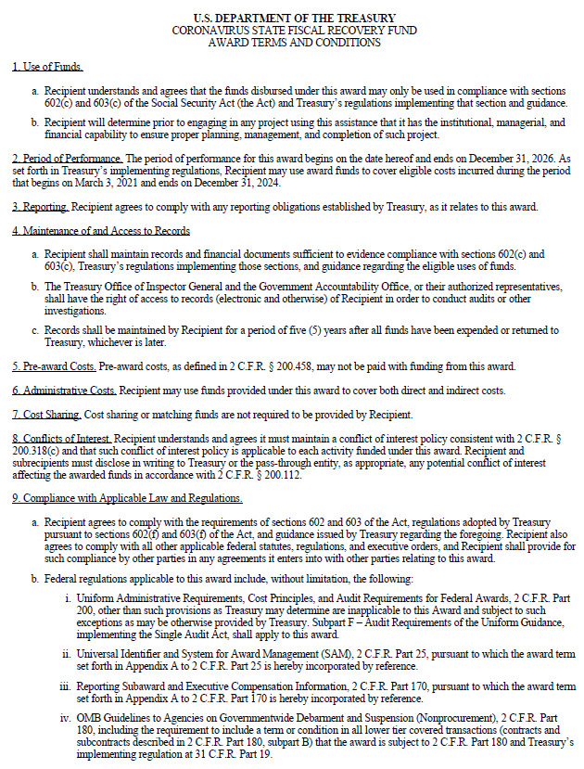
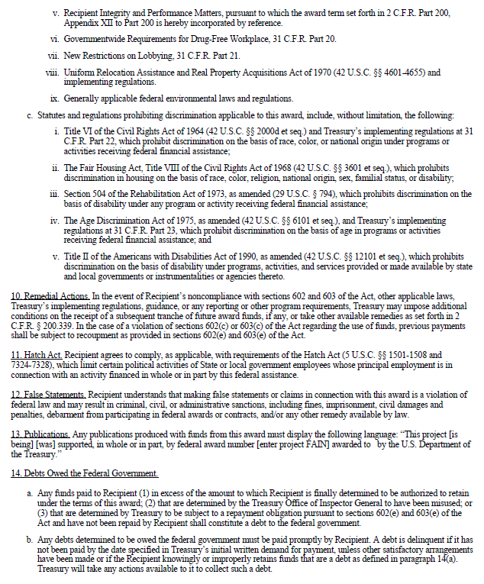

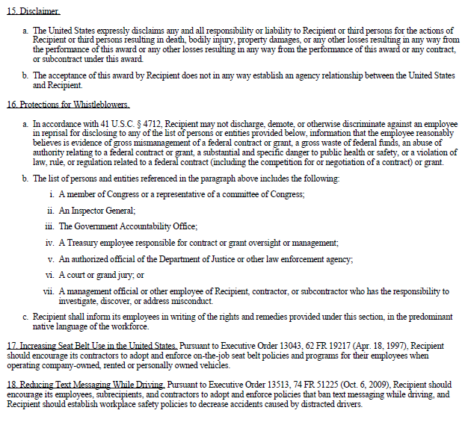

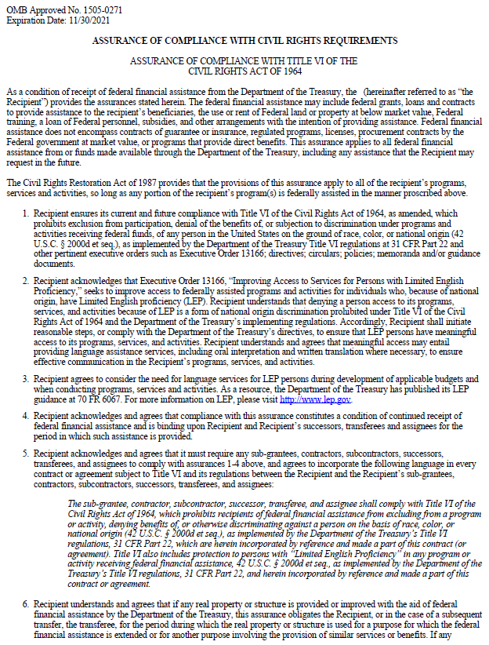

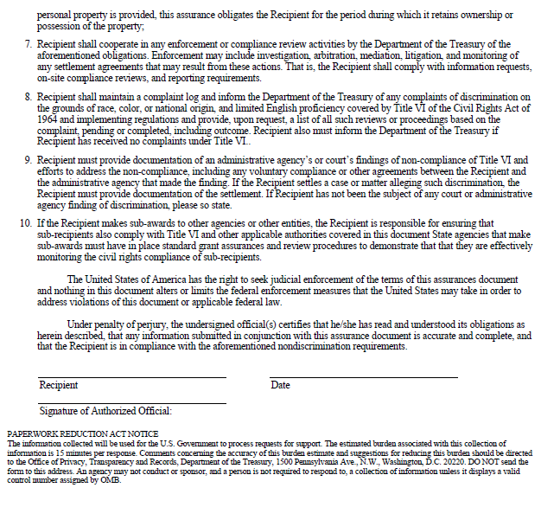
EXHIBIT D

GRANT INVOICING PROCEDURES

EXHIBIT E

REPORTING TERMS AND CONDITIONS

Grantee shall submit performance reports about the activities funded under this Agreement. Reports shall provide the necessary information by using the web portal established by the MORP for that purpose. The Recovery Office will meet with Grantee on quarterly basis to discuss performance, unless otherwise determined.

Performance Reports
All monthly reports of finances, expenditures, and performance measures on ARPA-funded projects should be submitted to the Mayor’s Office of Recovery Programs by the second Friday of each calendar month. Every month, Grantee will provide a narrative report on all project activities. Reporting frequency subject to change.

Reporting deadlines prior to the approval of the agreement by the Board of Estimates do not apply. Reporting deadlines after the end of the award term do not apply.

Calendar Year |  |  | Period of Activity | Monthly Report  Due Date
 | 2022 |  | April 1, 2022 - April 30, 2022 | May 13, 2022
 | 2022 |  | May 1, 2022 - May 31, 2022 | June 10, 2022
 | 2022 |  | June 1, 2022 - June 30, 2022 | July 8, 2022
 | 2022 |  | July 1, 2022 - July 31, 2022 | August 12, 2022
 | 2022 |  | August 1, 2022 - August 31, 2022 | September 9, 2022
 | 2022 |  | September 1, 2022 - September 30, 2022 | October 14, 2022
 | 2022 |  | October 1, 2022 - October 31, 2022 | November 14, 2022*
 | 2022 |  | November 1, 2022 - November 30, 2022 | December 9, 2022
 | 2022 |  | December 1, 2022 - December 31, 2022 | January 13, 2023
 | 2023 |  | January 1, 2023 - January 31, 2023 | February 10, 2023
 | 2023 |  | February 1, 2023 - February 28, 2023 | March 10, 2023
 | 2023 |  | March 1, 2023 - March 30, 2023 | April 14, 2023
 | 2023 |  | April 1, 2023 - April 30, 2023 | May 12, 2023
 | 2023 |  | May 1, 2023 - May 31, 2023 | June 9, 2023
 | 2023 |  | June 1, 2023 - June 30, 2023 | July 14, 2023
 | 2023 |  | July 1, 2023 - July 31, 2023 | August 11, 2023
 | 2023 |  | August 1, 2023 - August 31, 2023 | September 8, 2023
 | 2023 |  | September 1, 2023 - September 30, 2023 | October 13, 2023
 | 2023 |  | October 1, 2023 - October 31, 2023 | November 13, 2023*
 | 2023 |  | November 1, 2023 - November 30, 2023 | December 8, 2023
 | 2023 |  | December 1, 2023 - December 31, 2023 | January 12, 2024
 | 2024 |  | January 1, 2024 – January 31, 2024 | February 9, 2024
 | 2024 |  | February 1, 2024 – February 28, 2024 | March 8, 2024
 | 2024 |  | March 1, 2024 – March 31, 2024 | April 12, 2024
 | 2024 |  | April 1, 2024 – April 30, 2024 | May 10, 2024
 | 2024 |  | May 1, 2024 – May 31, 2024 | June 14, 2024
 | 2024 |  | June 1, 2024 – June 30, 2024 | July 12, 2024
 | 2024 |  | July 1, 2024 – July 31, 2024 | August 9, 2024
 | 2024 |  | August 1, 2024 – August 31, 2024 | September 13, 2024
 | 2024 |  | September 1, 2024 – September 30, 2024 | October 11, 2024
 | 2024 |  | October 1, 2024 – October 31, 2024 | November 8, 2024
 | 2024 |  | November 1, 2024 – November 30, 2024 | December 13, 2024
 | 2024 |  | December 1, 2024 – December 31, 2024 | January 10, 2025
 | 2025 |  | January 1, 2025 – January 31, 2025 | February 14, 2025
 | 2025 |  | February 1, 2025 – February 28, 2025 | March 14, 2025
 | 2025 |  | March 1, 2025 – March 31, 2025 | April 11, 2025
 | 2025 |  | April 1, 2025 – April 30, 2025 | May 9, 2025
 | 2025 |  | May 1, 2025 – May 31, 2025 | June 13, 2025
 | 2025 |  | June 1, 2025 – June 30, 2025 | July 11, 2025
 | 2025 |  | July 1, 2025 – July 31, 2025 | August 15, 2025
 | 2025 |  | August 1, 2025 – August 31, 2025 | September 12, 2025
 | 2025 |  | September 1, 2025 – September 30, 2025 | October 10, 2025
 | 2025 |  | October 1, 2025 – October 31, 2025 | November 14, 2025
 | 2025 |  | November 1, 2025 – November 30, 2025 | December 12, 2025
 | 2026 |  | December 1, 2025 – December 31, 2025 | January 9, 2026
 | 2026 |  | January 1, 2026 – January 31, 2026 | February 13, 2026
 | 2026 |  | February 1, 2026 – February 28, 2026 | March 13, 2026
 | 2026 |  | March 1, 2026 – March 31, 2026 | April 10, 2026
 | 2026 |  | April 1, 2026 – April 30, 2026 | May 8, 2026
 | 2026 |  | May 1, 2026 – May 31, 2026 | June 12, 2026
 | 2026 |  | June 1, 2026 – June 30, 2026 | July 10, 2026
 | 2026 |  | July 1, 2026 – July 31, 2026 | August 14, 2026
 | 2026 |  | August 1, 2026 – August 31, 2026 | September 11, 2026
 | 2026 |  | September 1, 2026 – September 30, 2026 | October 9, 2026
 | 2026 |  | October 1, 2026 – October 31, 2026 | November 13, 2026
 | 2026 |  | November 1, 2026 – November 30, 2026 | December 11, 2026
 | 2027 |  | December 1, 2026 – December 31, 2026 | January 8, 2027
* Deadline modified due to a holiday on the second Friday of the month.

Expenditure Category: [LIST EXPENDITURE CATEGORY]

Performance reports shall provide the following information: [LIST PERFORMANCE MEASURES]

EXHIBIT F

GRANTEE’S COMMITMENT TO COMPLY / WAIVER

EXHIBIT G

LOCAL HIRING LAW AND THE LOCAL HIRING RULES AND REGULATIONS

(NOT APPLICABLE)

